AMMA-2050 Climate Metrics Atlas v0.2.1

# About this version

This is a preliminary release for Dave and Chris to review plots, and suggest improvements and additions. It is intended to provide a first look at the revised plots, and identify actions to complete before v0.2.2 is released in late September 2017. Please add to the lists of ‘TODO’ items below each plot. The following variables have been sub-selected for the purposes of this review:

* Region: Burkina Faso
* Scenario: rcp8.5
* Bias correction method: BC_0.5x0.5 (bias corrected and disaggregated to 0.5˚)
* Season: JAS (with the exception of the onset index)
* Metrics:
  + Number of hot days (tasmax > 40˚C)
  + Maximum seasonal precipitation
  + Monsoon onset data (Marteau method)

The following list describes briefly all the plots (and various sub-types) that we have currently produced.

* Plots for each variable (sub-divided by the data shown):
  + Boxplots of:
    - absolute anomaly by scenario
    - % anomaly by scenario
    - historical vs scenarios
  + Histograms of:
    - absolute anomaly (one scenario)
    - % anomaly by scenario
    - historical vs scenarios side-by-side
  + Model ranking scatterplots of:
    - Each scenario (and historical) individually
    - Absolute anomaly (one scenario)
    - % anomaly (one scenario)
  + Spaghetti timeseries of:
    - All scenarios for 1950-2100
  + Maps of ensemble spread (10th and 90th percentiles):
    - Each scenario (and historical) individually
    - Absolute anomaly (one scenario)
    - % anomaly (one scenario)
  + ‘Number of model’ histograms of:
    - Absolute anomaly (one scenario)
    - % anomaly (one scenario)

In the latest version of the code, the old GUI has been greatly simplified, and all the code written by African partners has been retained. Additionally, the plotting code written by African partners during the Leeds workshop was used as a starting point for v0.1 of the atlas, and has subsequently been refined for the version (v0.2.1). To give an idea of the scale of the task, the following table summarises the python files, number of functions and lines of code involved.

|  |  |  |
| --- | --- | --- |
| **Script name** | **No. of functions** | **No. of lines** |
| calc.py | 18 | 585 |
| constants.py | 0 | 32 |
| labeller.py | 3 | 86 |
| master.py | 4 | 175 |
| mplot.py | 10 | 722 |
| utils.py | 10 | 230 |
| writeNetcdf.py | 4 | 134 |
| **Total** | **49** | **1964** |

# Number of hot days (tasmax > 40˚C)

## Boxplots

### Absolute anomaly by scenario

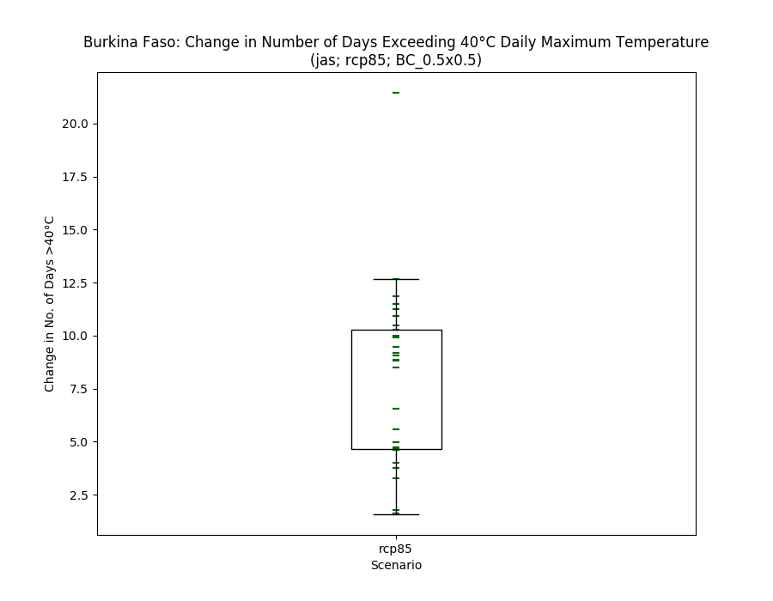

* Currently only shows 1 scenario, but will show more when they are processed
* Median line removed intentionally, box shows inter-quartile range

### % anomaly by scenario

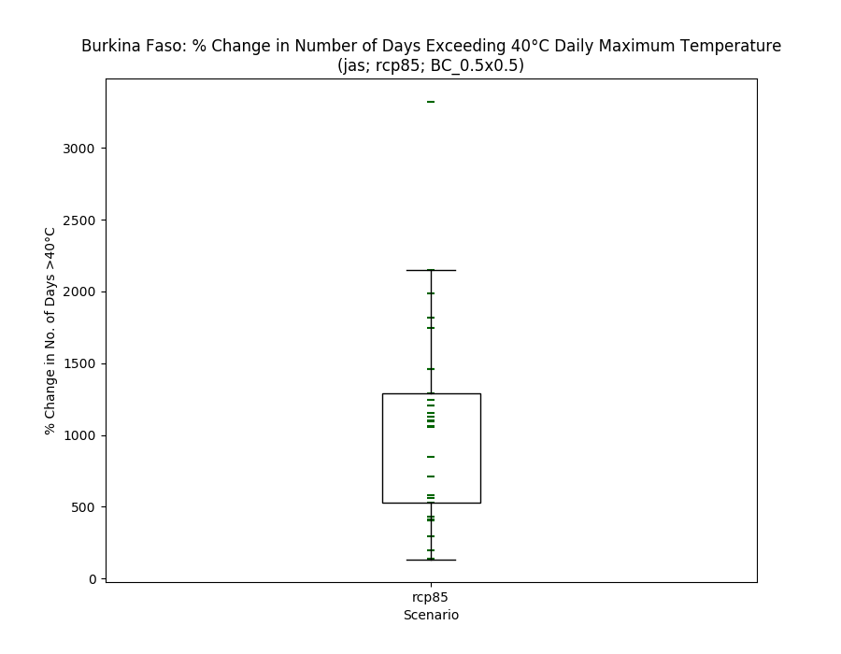

* Perhaps this is not appropriate to show % change in the number of days?

### Historical vs scenarios

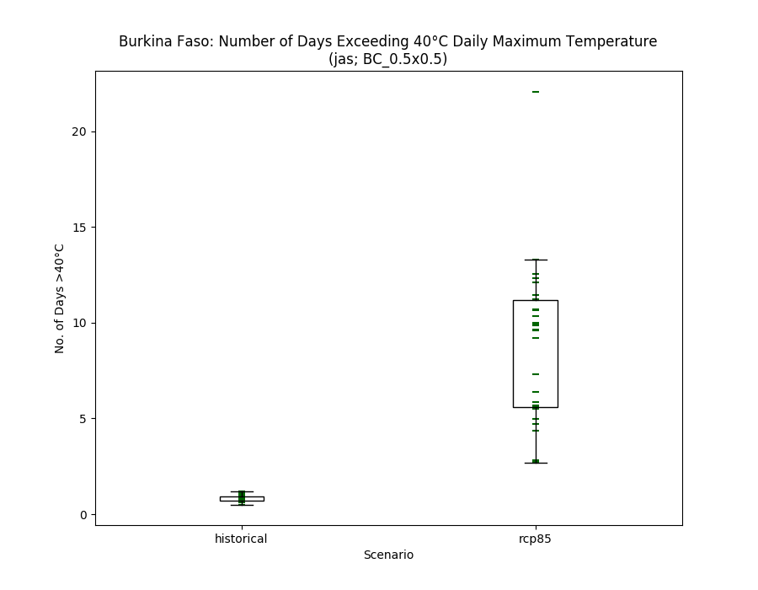

## Histograms

### Absolute anomaly (one scenario)

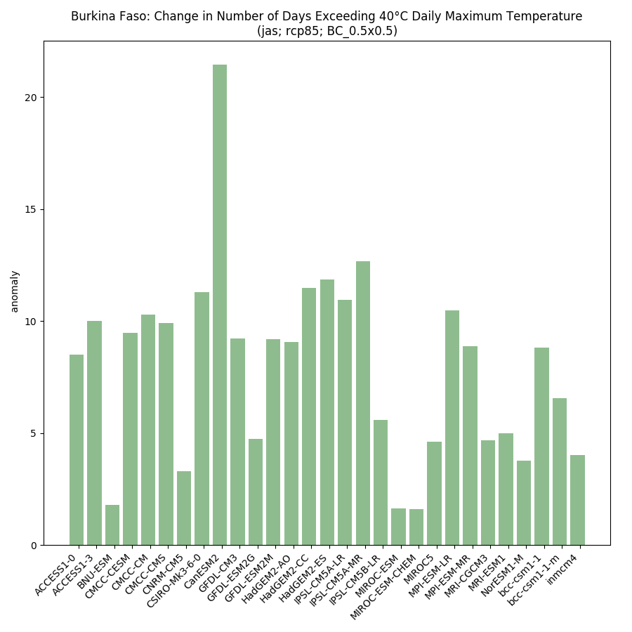

* Y-axis needs to be changed to ‘Number of days’
* The value is actually the number of days per year that the threshold was exceeded, averaged over the climatological period (1950-2000 for hist; 2040-2069 fut)
* Colours OK?

### % anomaly by scenario

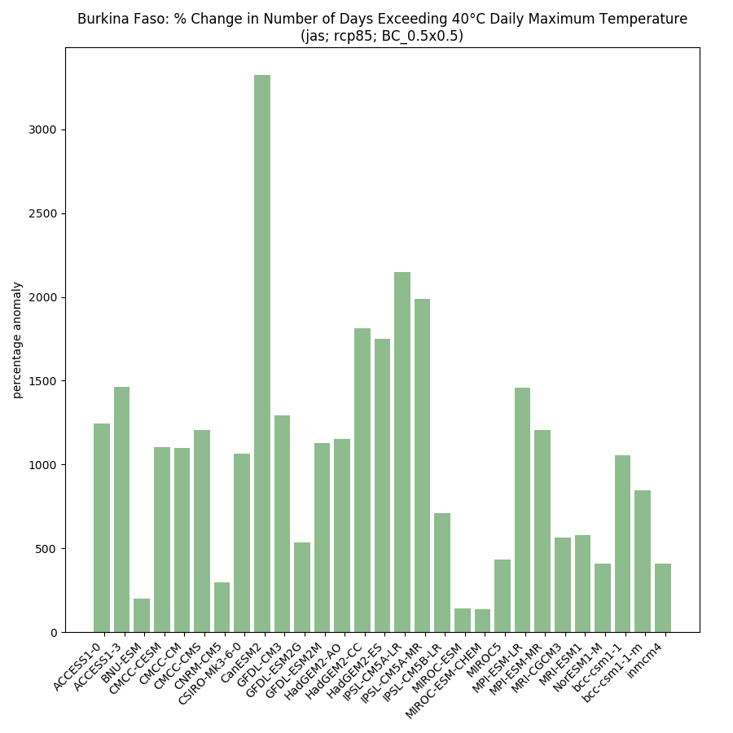

* As above, is it valid to show a % of a count?

### Historical vs scenarios side-by-side

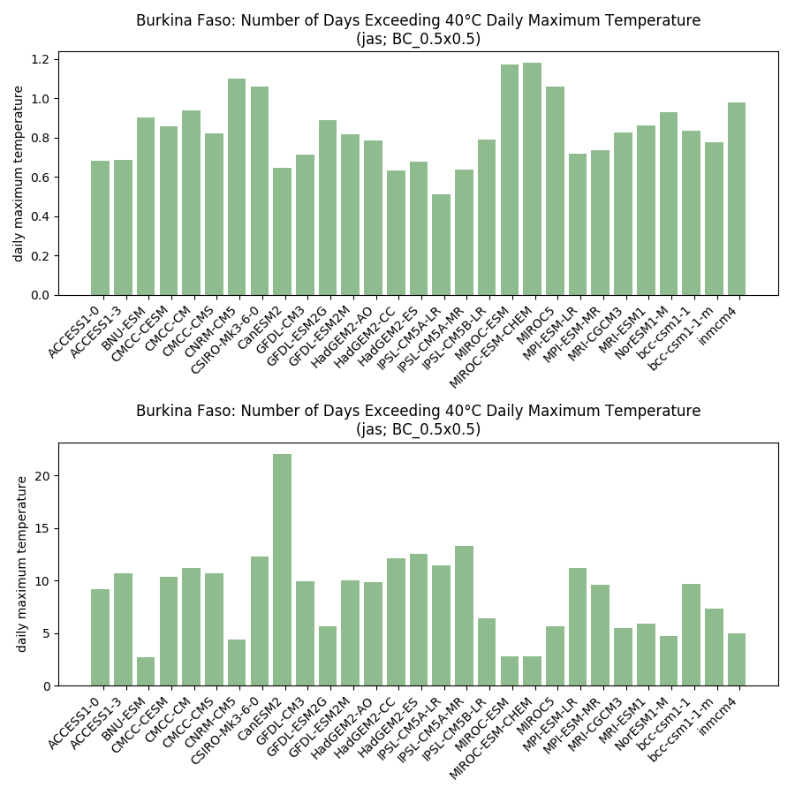

* Share the same y-axis between the two plots?
* Make sure the models match up between hist and all senarios

## Model ranking scatterplots

### Each scenario (and historical) individually

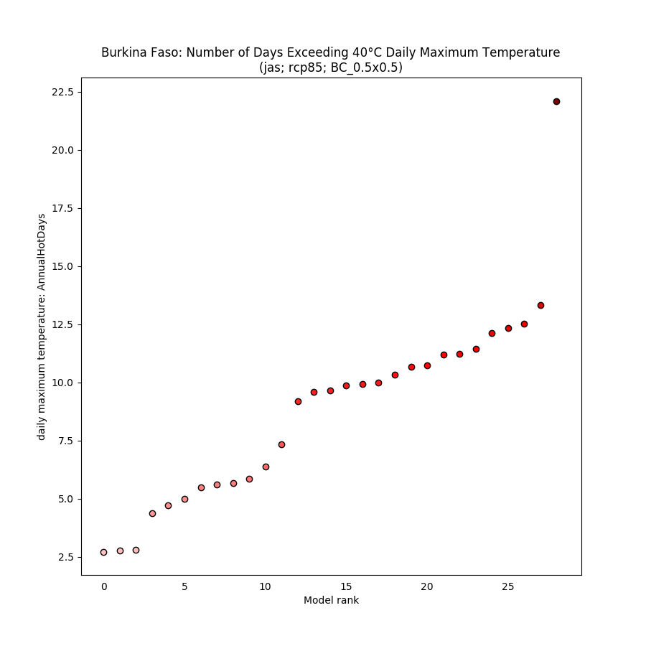

* Labelling the points could be interesting (but tricky!)
* How else can we make this look a bit more exciting?!
* Y-axis needs a better label

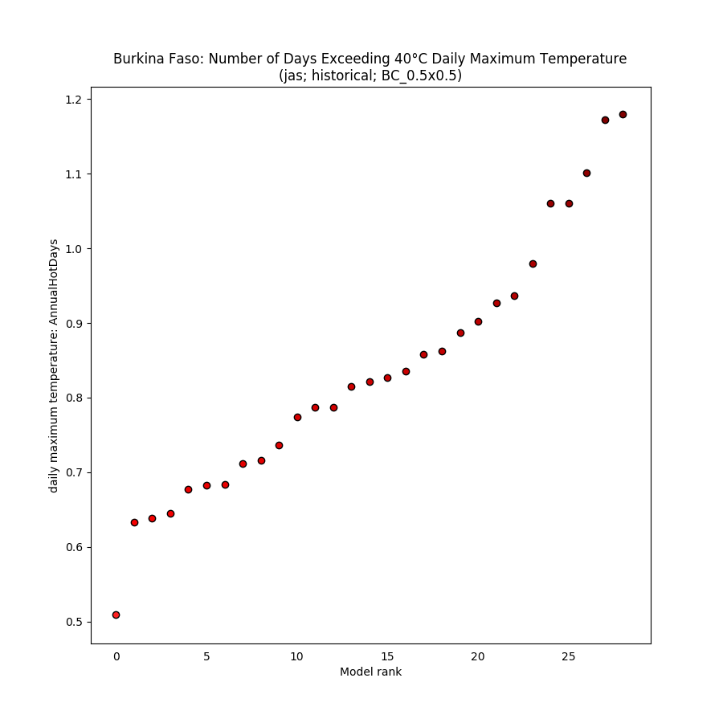

### Absolute anomaly (one scenario)

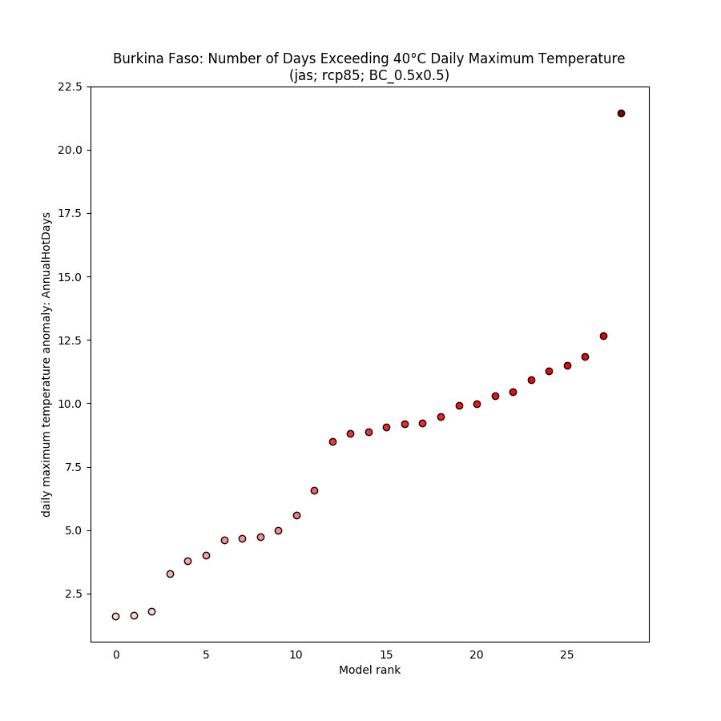

### % anomaly (one scenario)

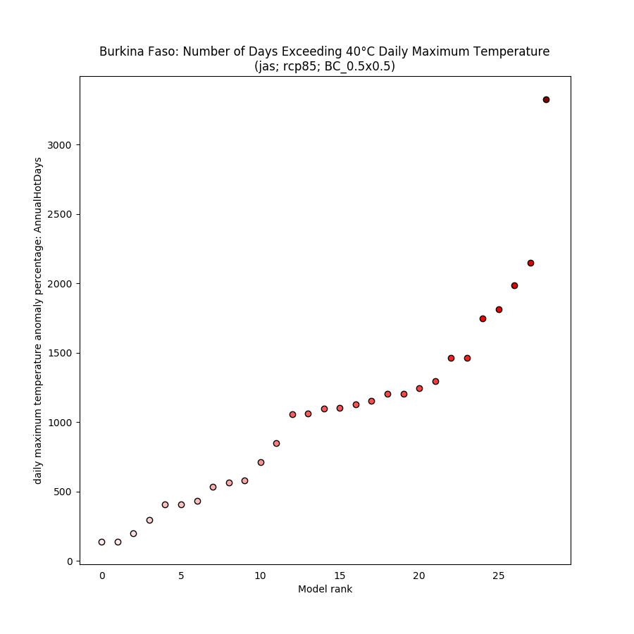

## Spaghetti timeseries

### All scenarios for 1950-2100

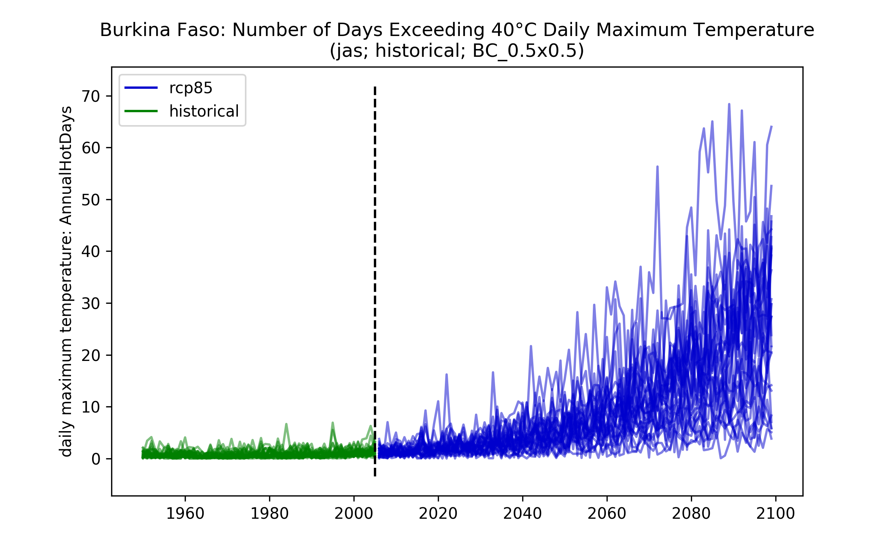

* One plot per scenario – might be useful to plot the 10th and 90th percentiles on here?
* Could we combine the 10-90th p/c for all scenarios on to one plot?
* Y-axis needs fixing
* X-axis label?

## Maps of ensemble spread (10th and 90th percentiles)

### Each scenario (and historical) individually

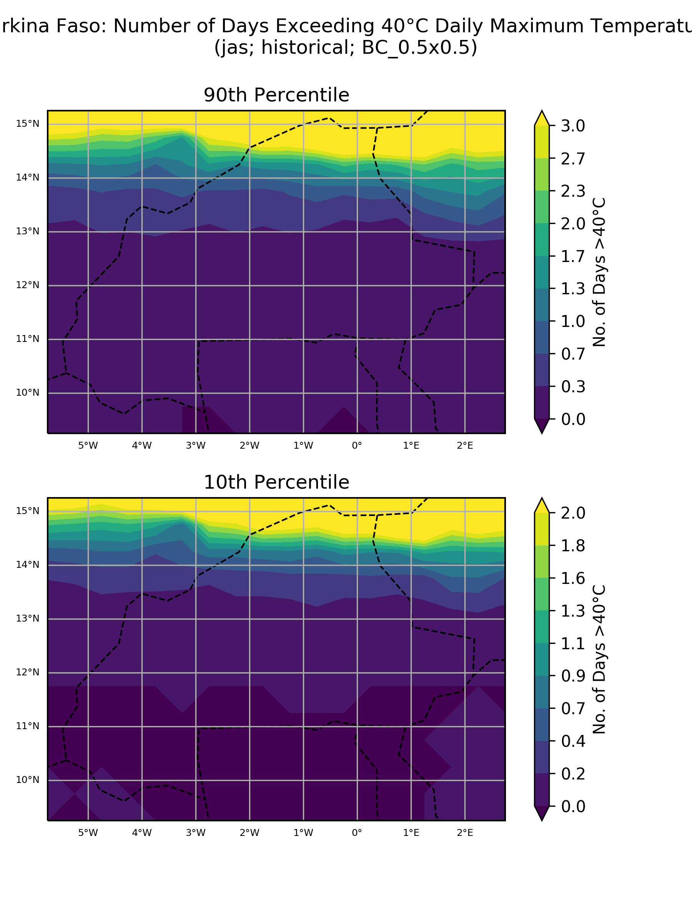

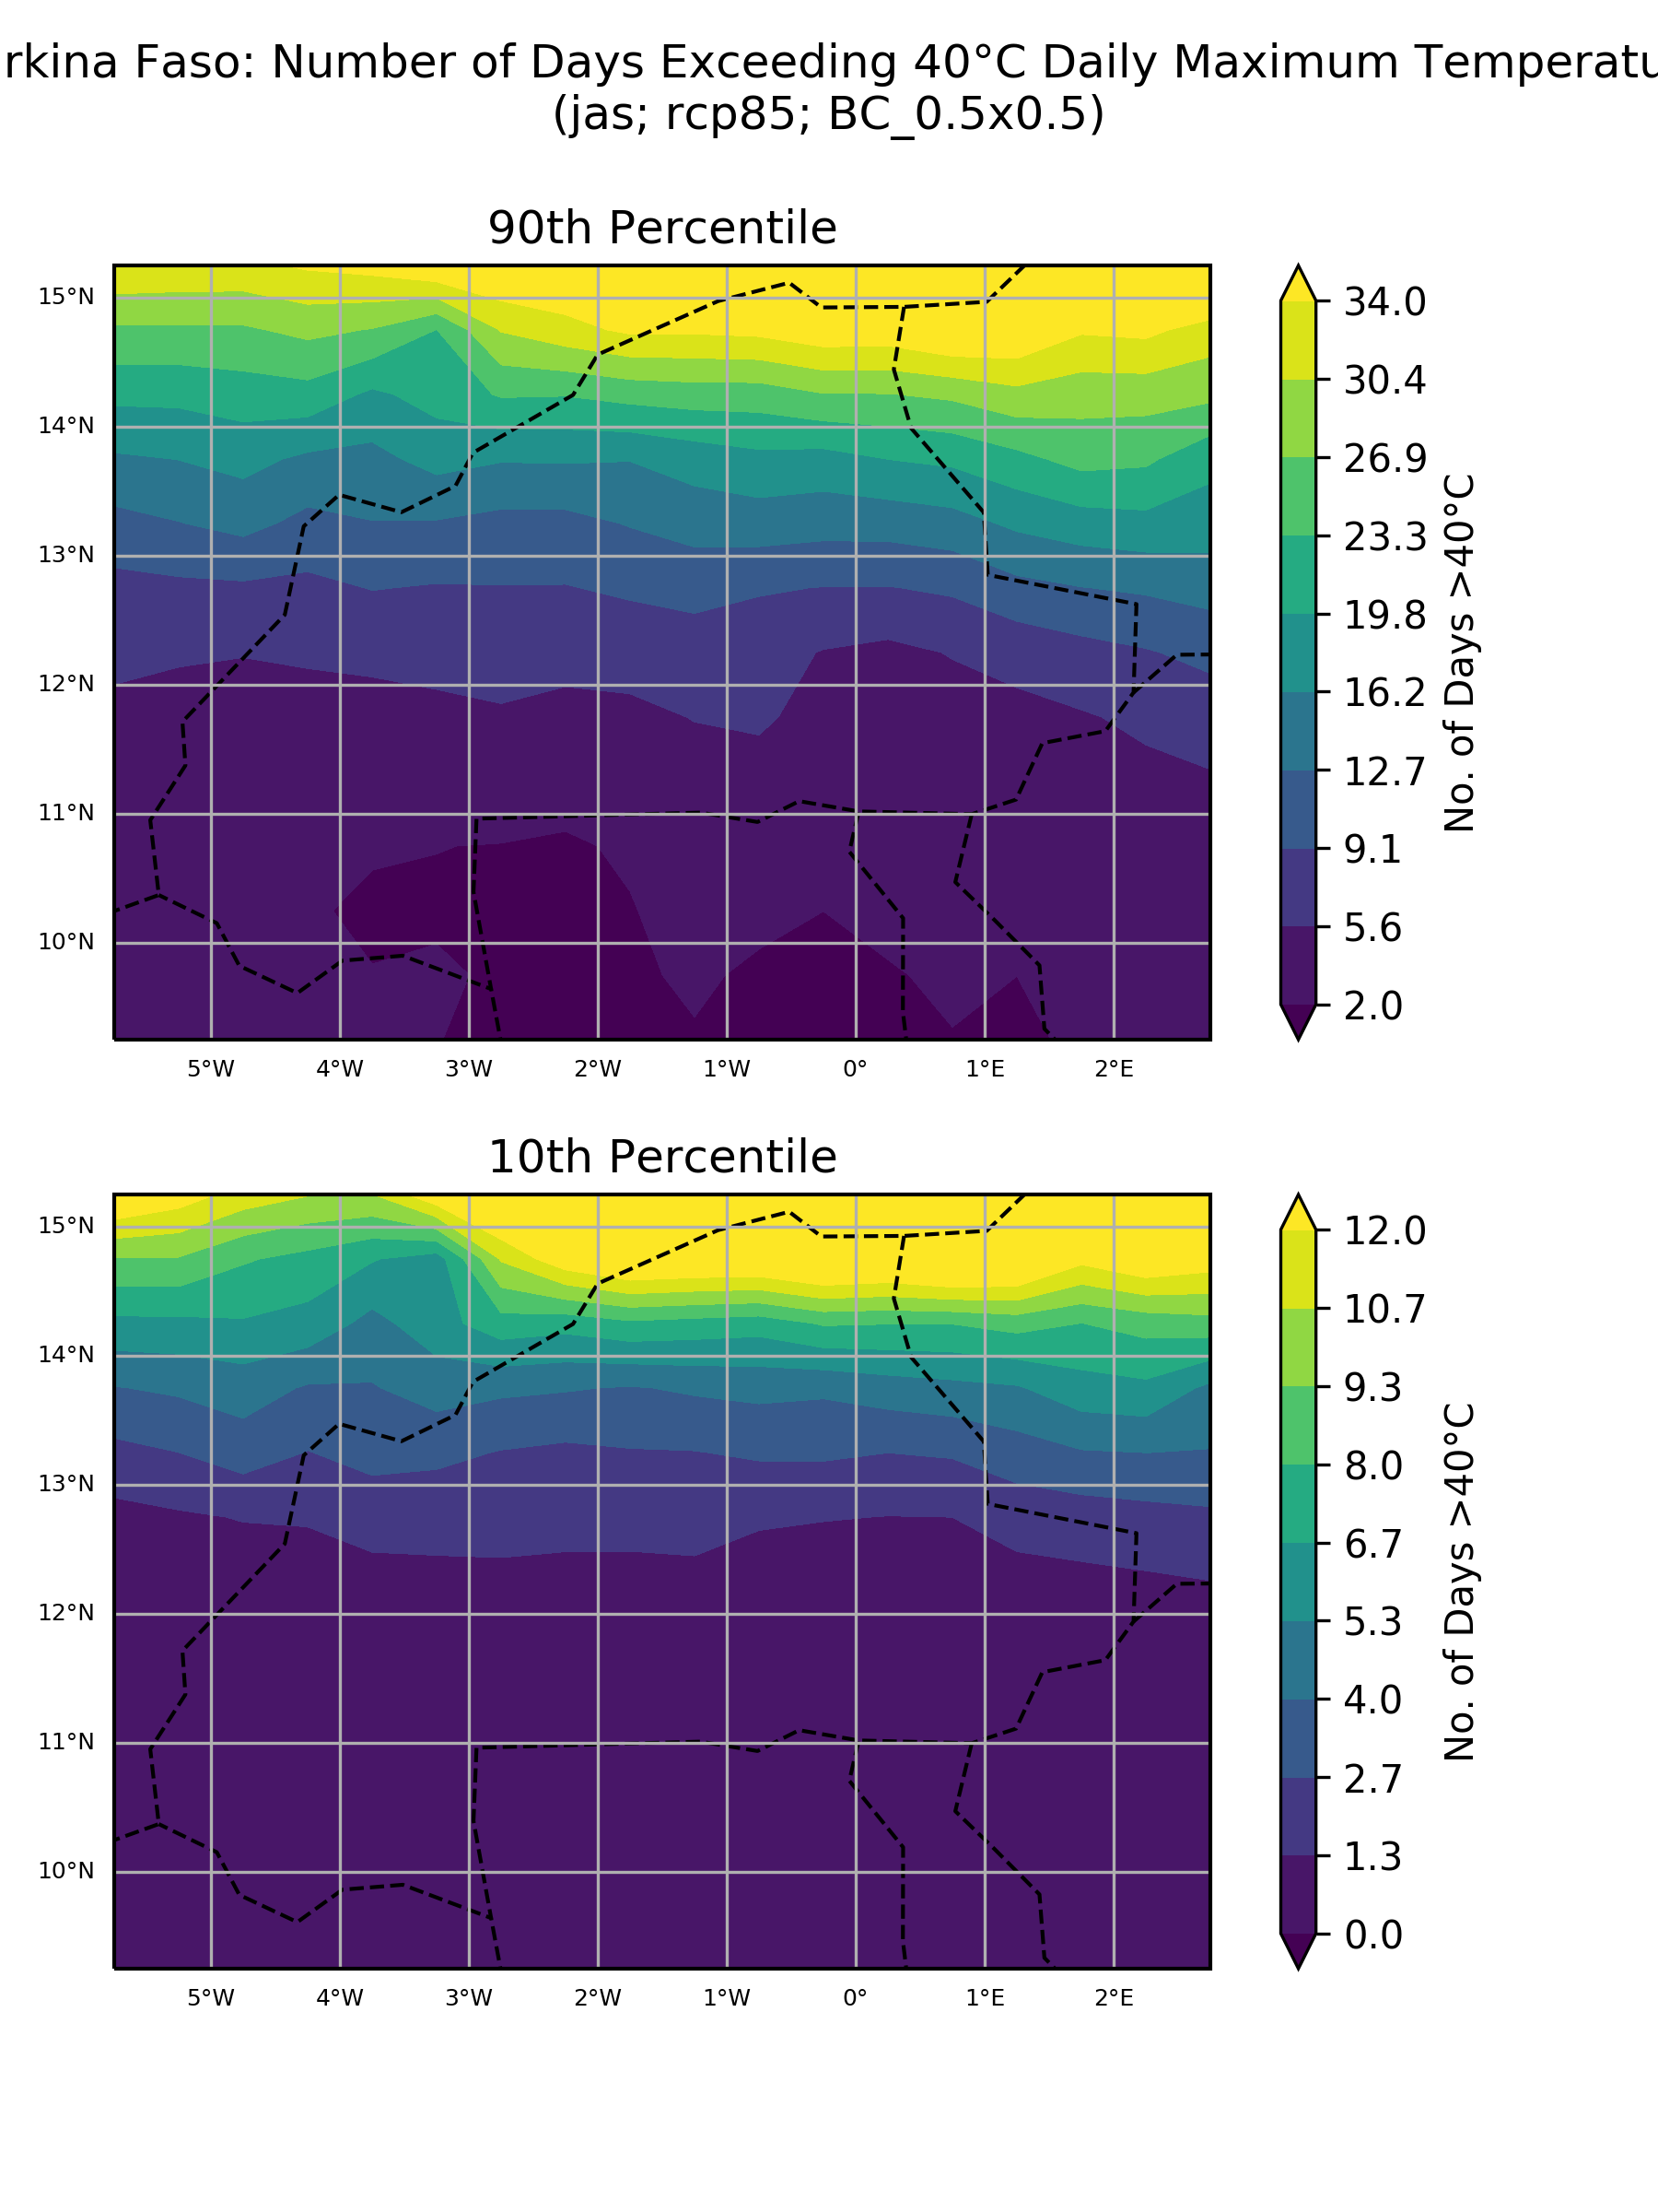

* Same colour scale for 10 and 90th percentiles? Same also for hist-rcp comparison?
* Title over-shoot
* Cities or sub-regions?

### Absolute anomaly (one scenario)

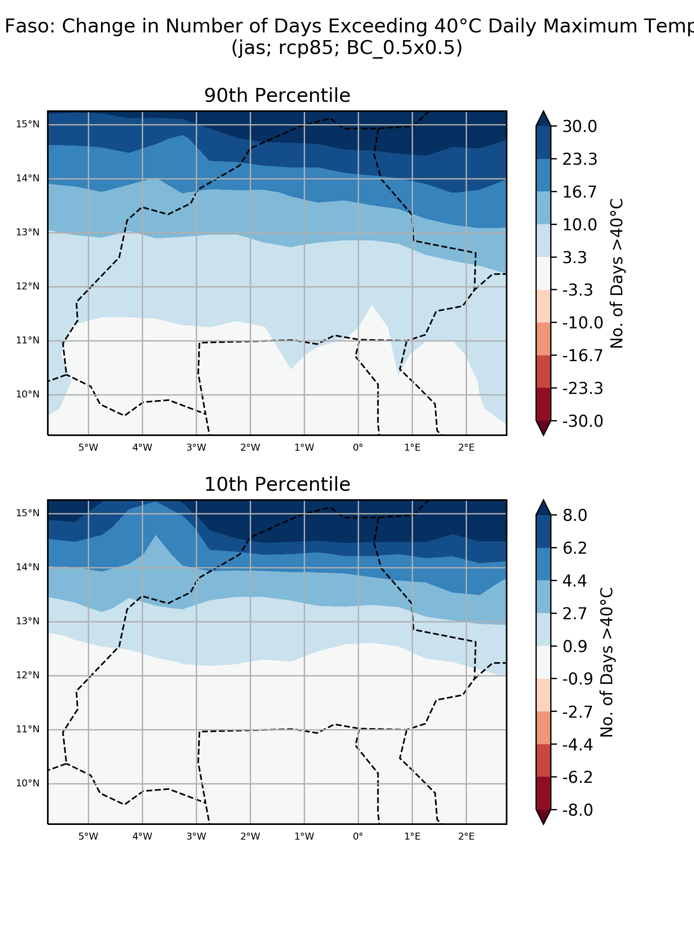

* Title over-shoot
* Same colour scale needed

### % anomaly (one scenario)

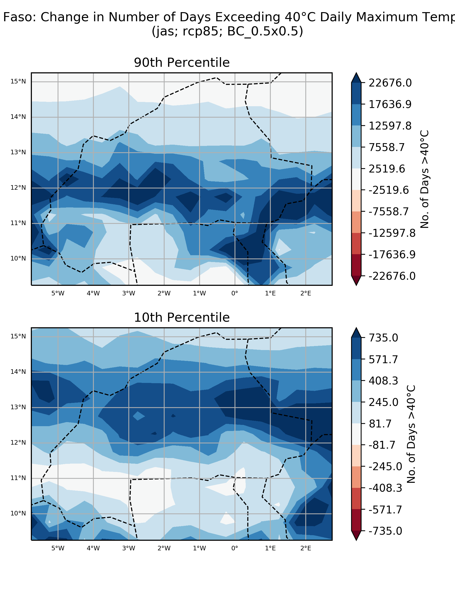

## ‘Number of model’ histograms

### Absolute anomaly (one scenario)

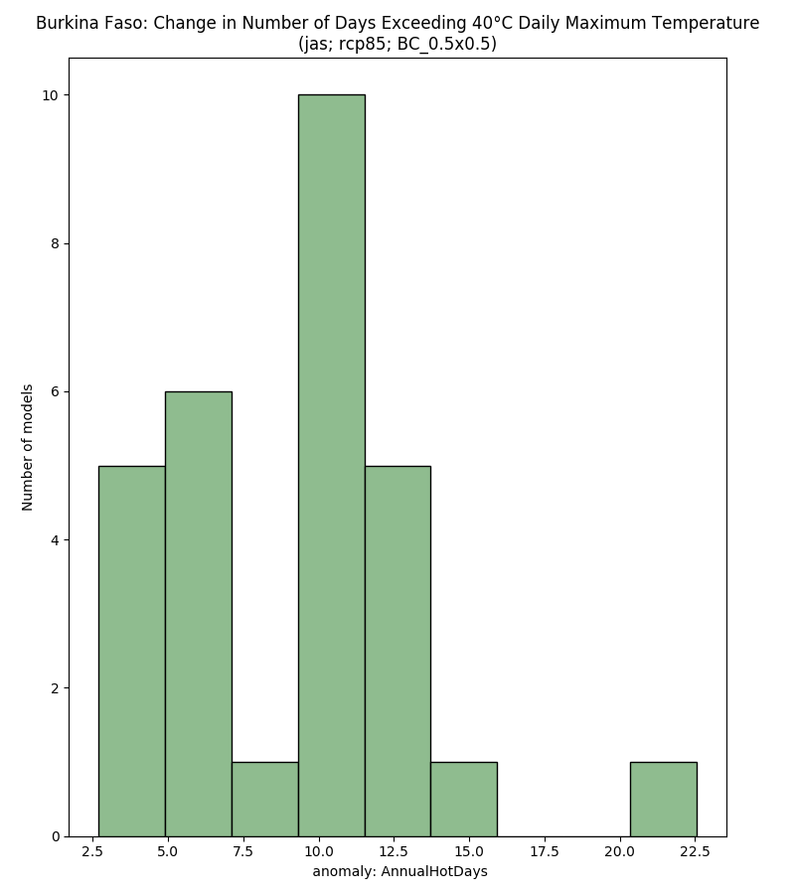

* X-axis label needed
* Colours a bit boring?
* X-axis tick marks don’t match up with bars

### % anomaly (one scenario)

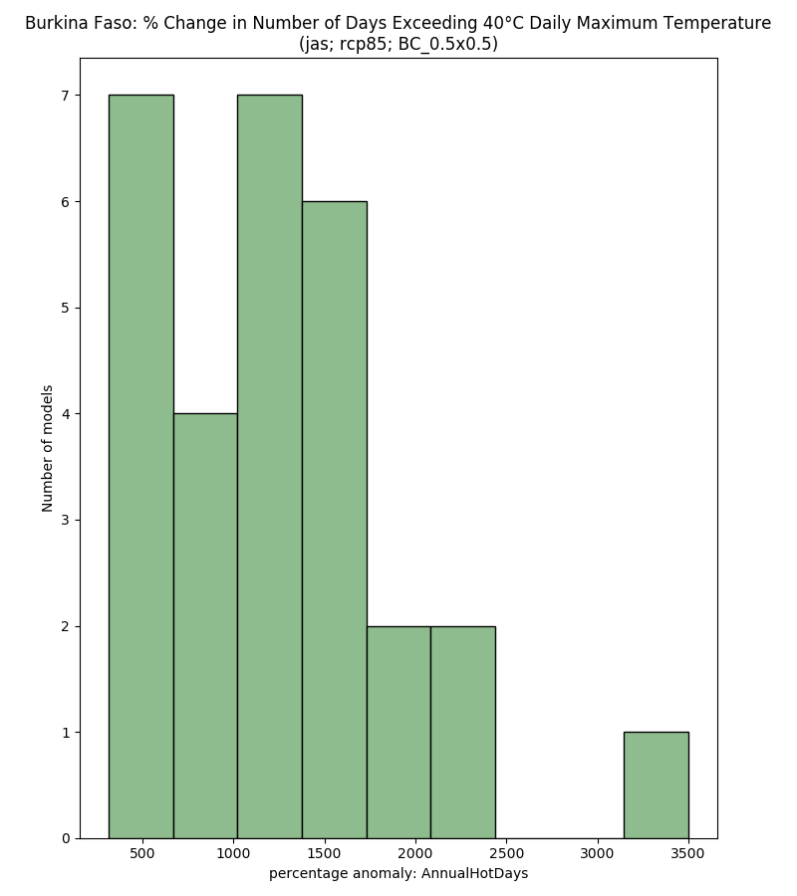

# Maximum Seasonal Precipitation

## Boxplots

### Absolute anomaly by scenario

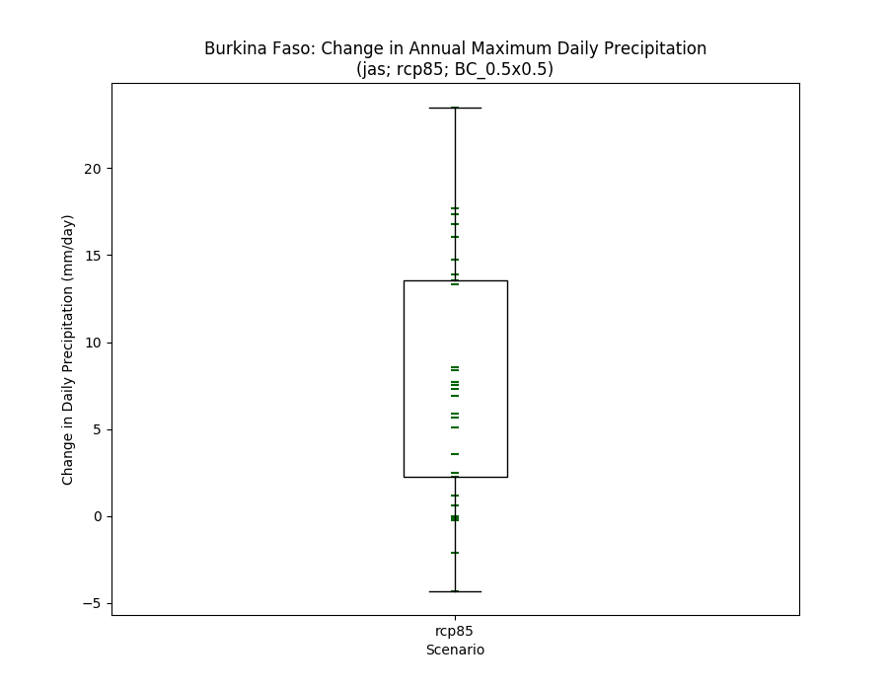

### % anomaly by scenario

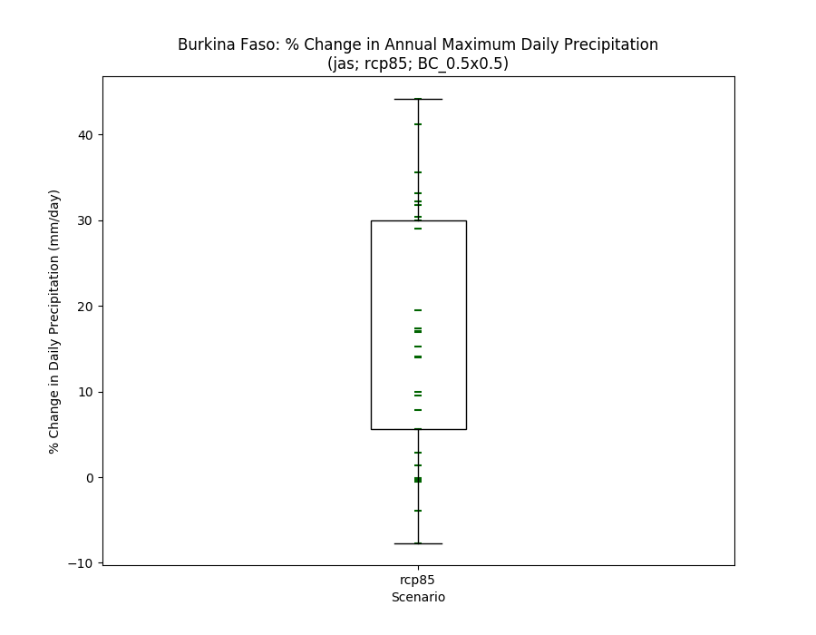

### Historical vs scenarios

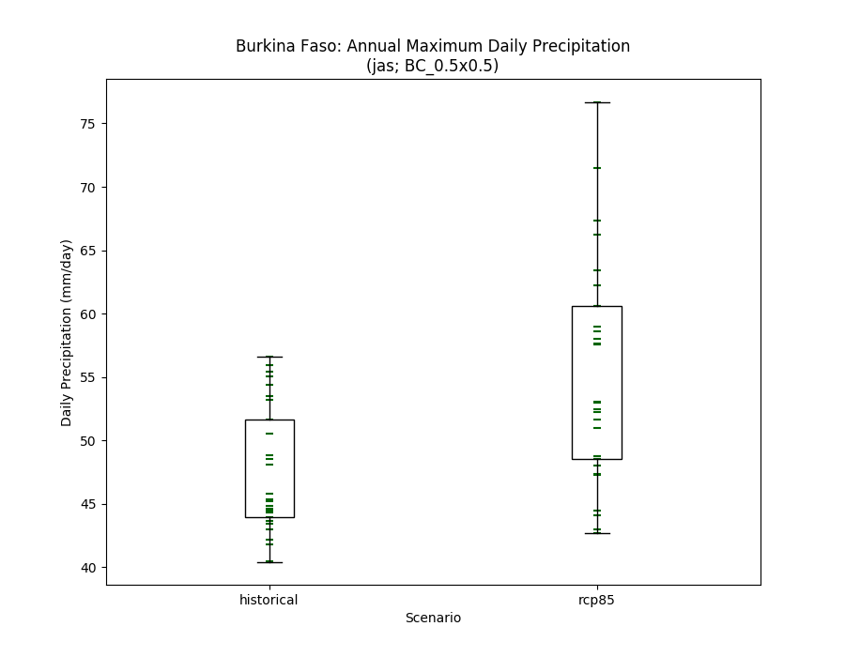

## Histograms

### Absolute anomaly (one scenario)

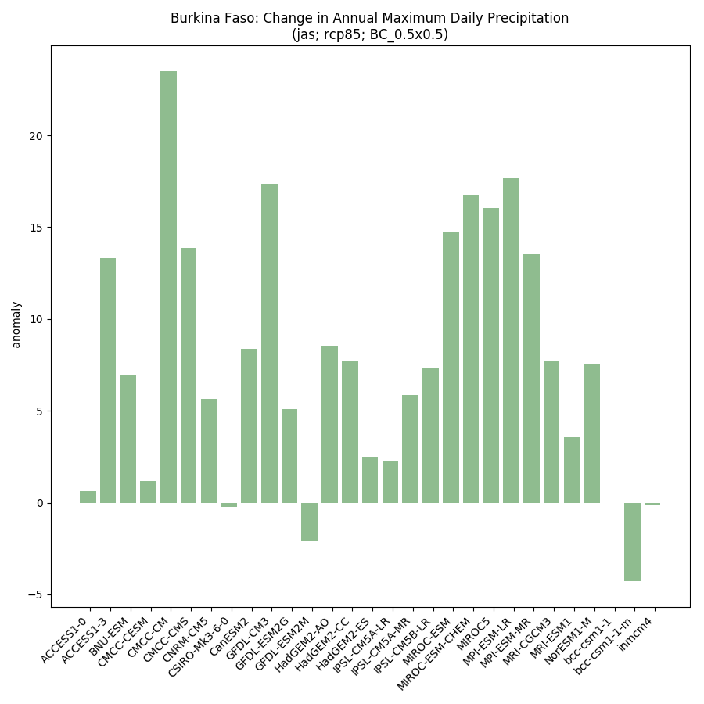

### % anomaly by scenario

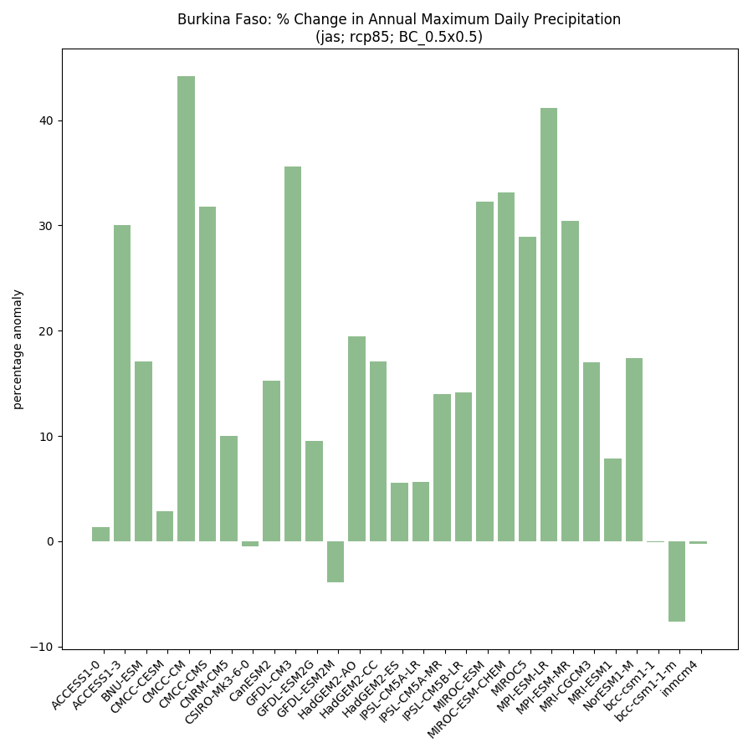

### Historical vs scenarios side-by-side

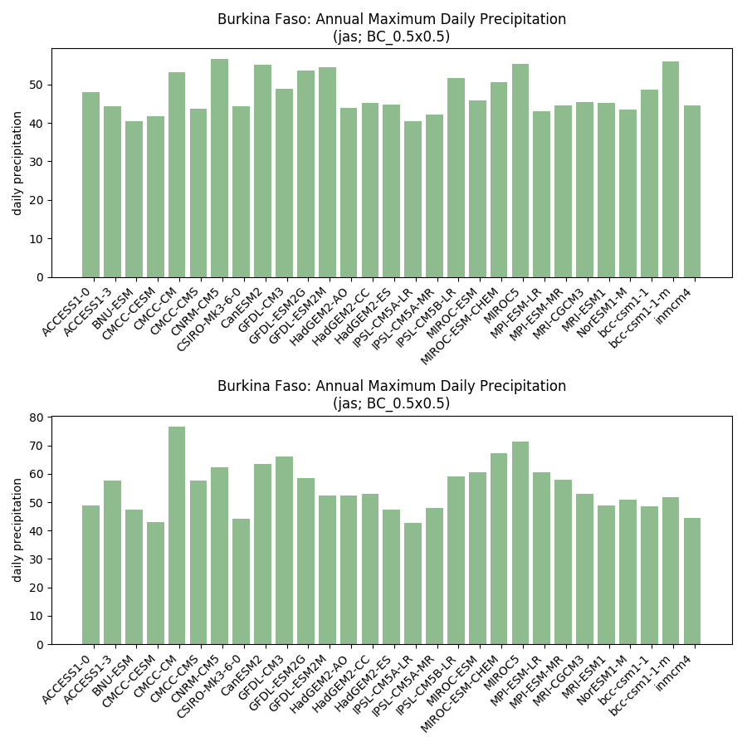

## Model ranking scatterplots

### Each scenario (and historical) individually

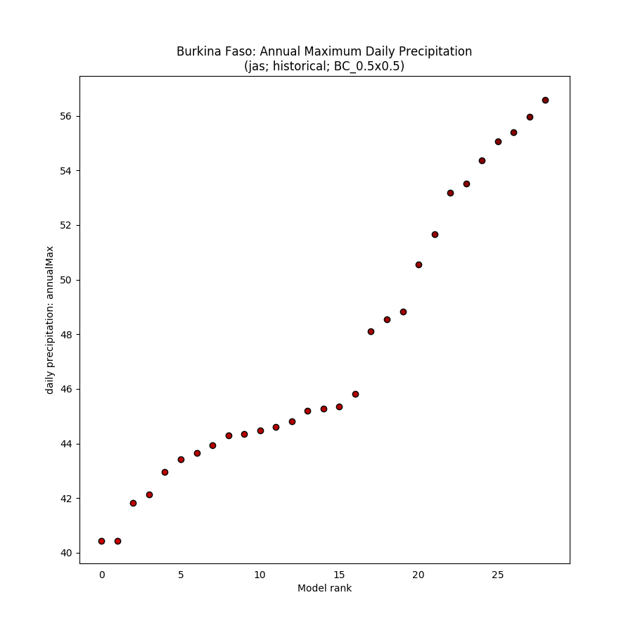

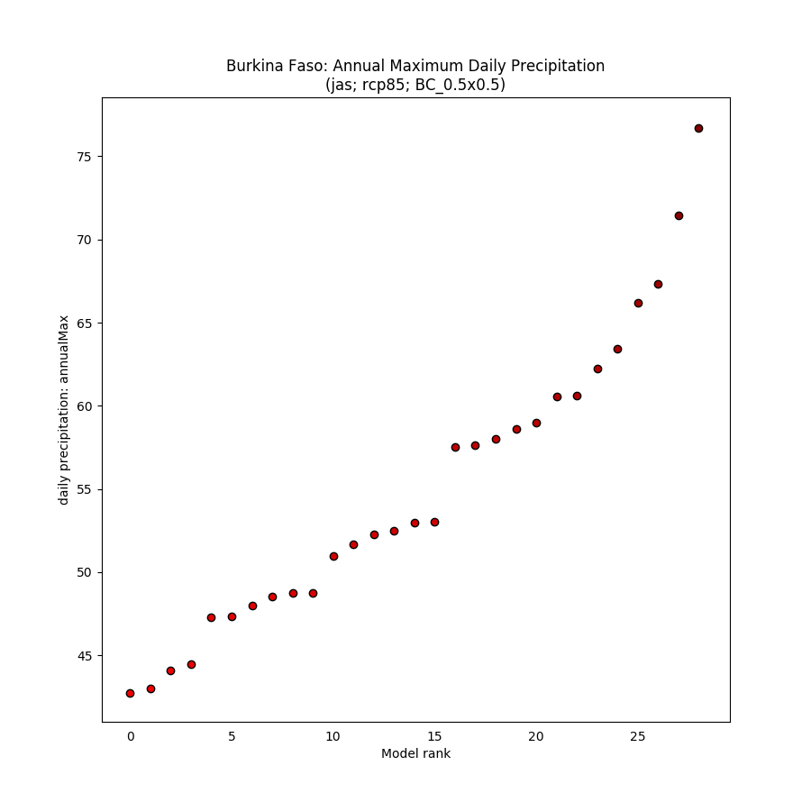

### Absolute anomaly (one scenario)

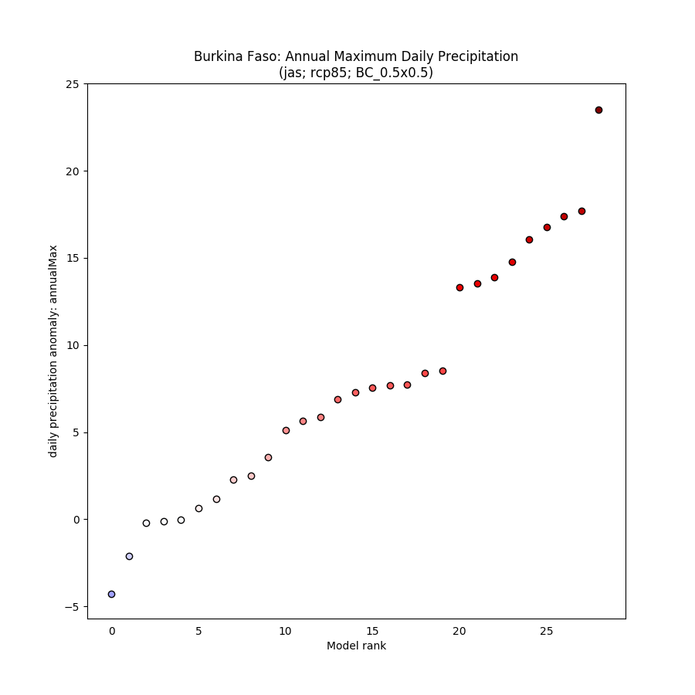

### % anomaly (one scenario)

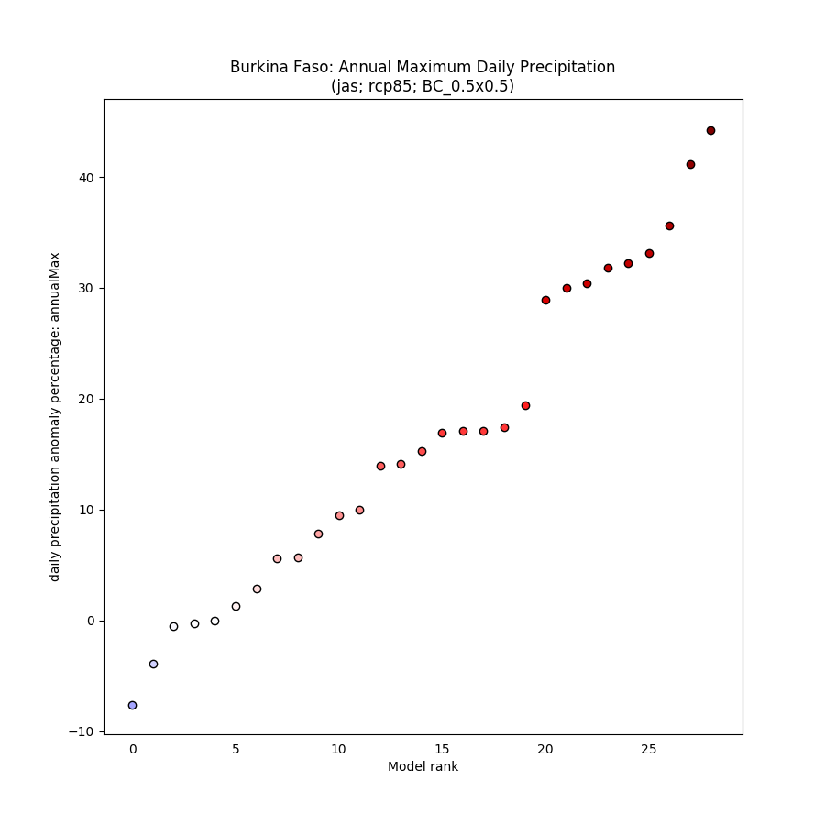

## Spaghetti timeseries

### All scenarios for 1950-2100

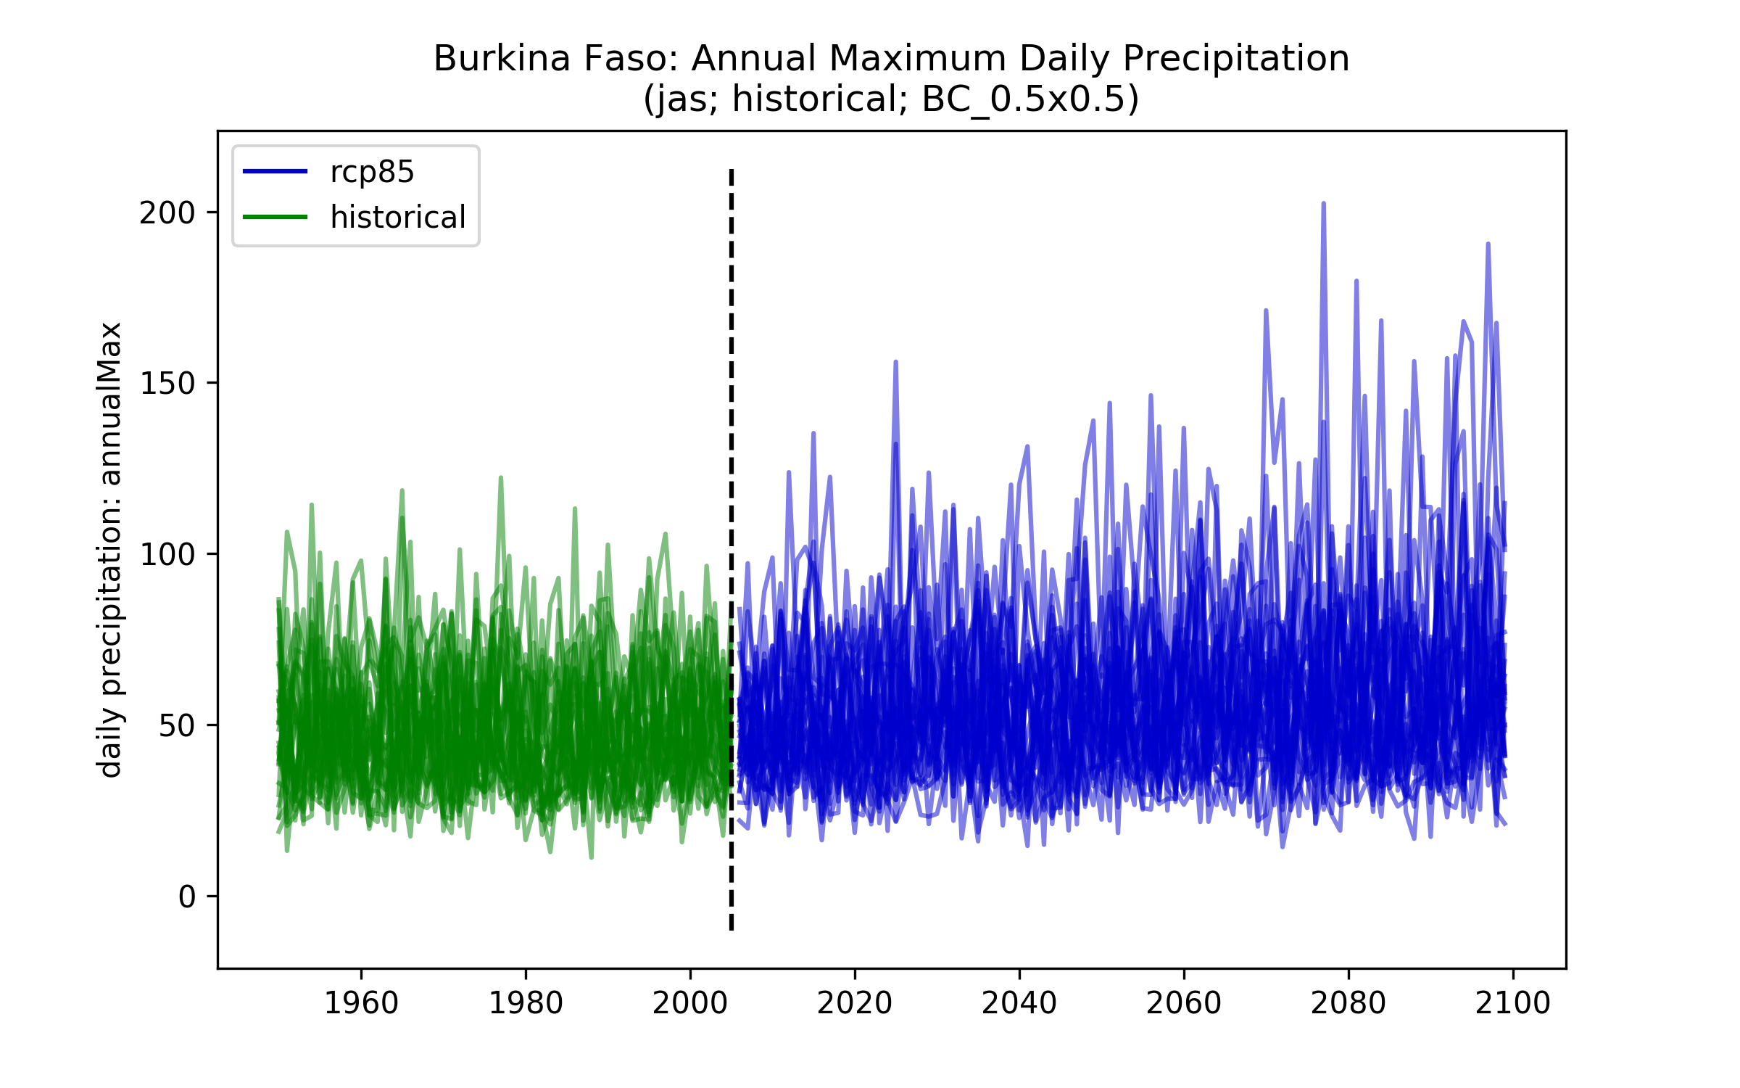

## Maps of ensemble spread (10th and 90th percentiles)

### Each scenario (and historical) individually

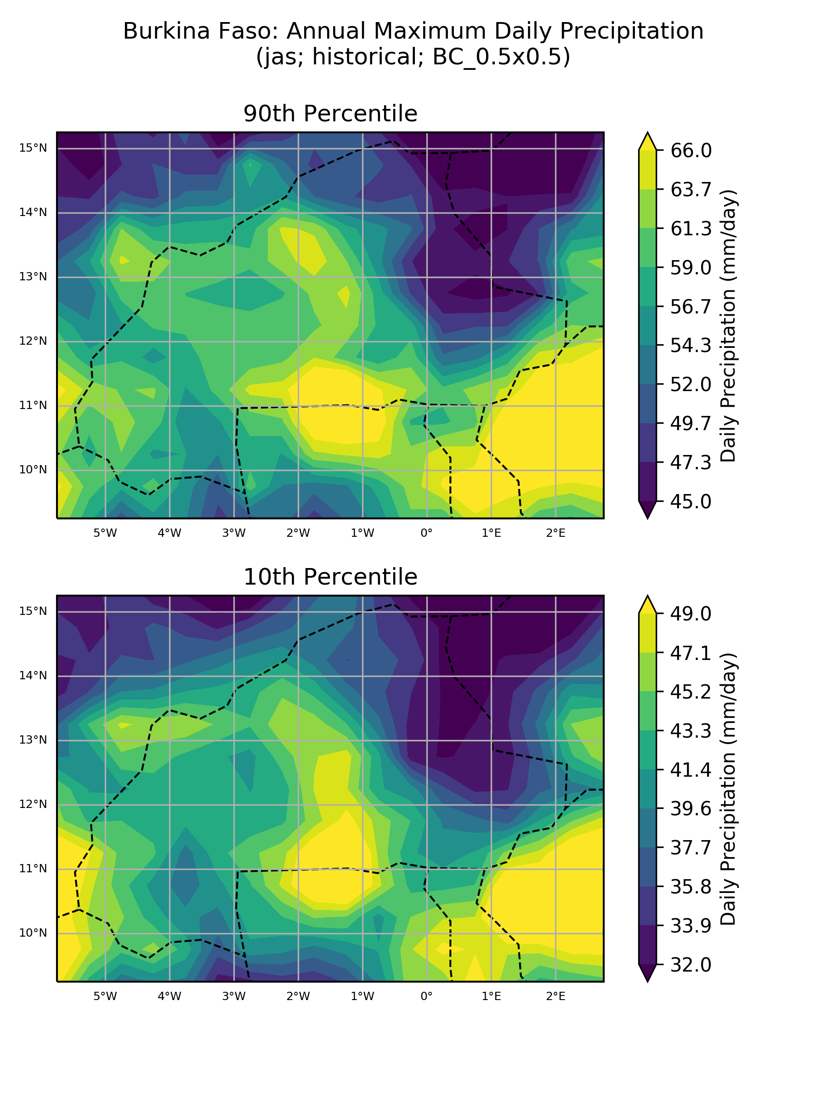

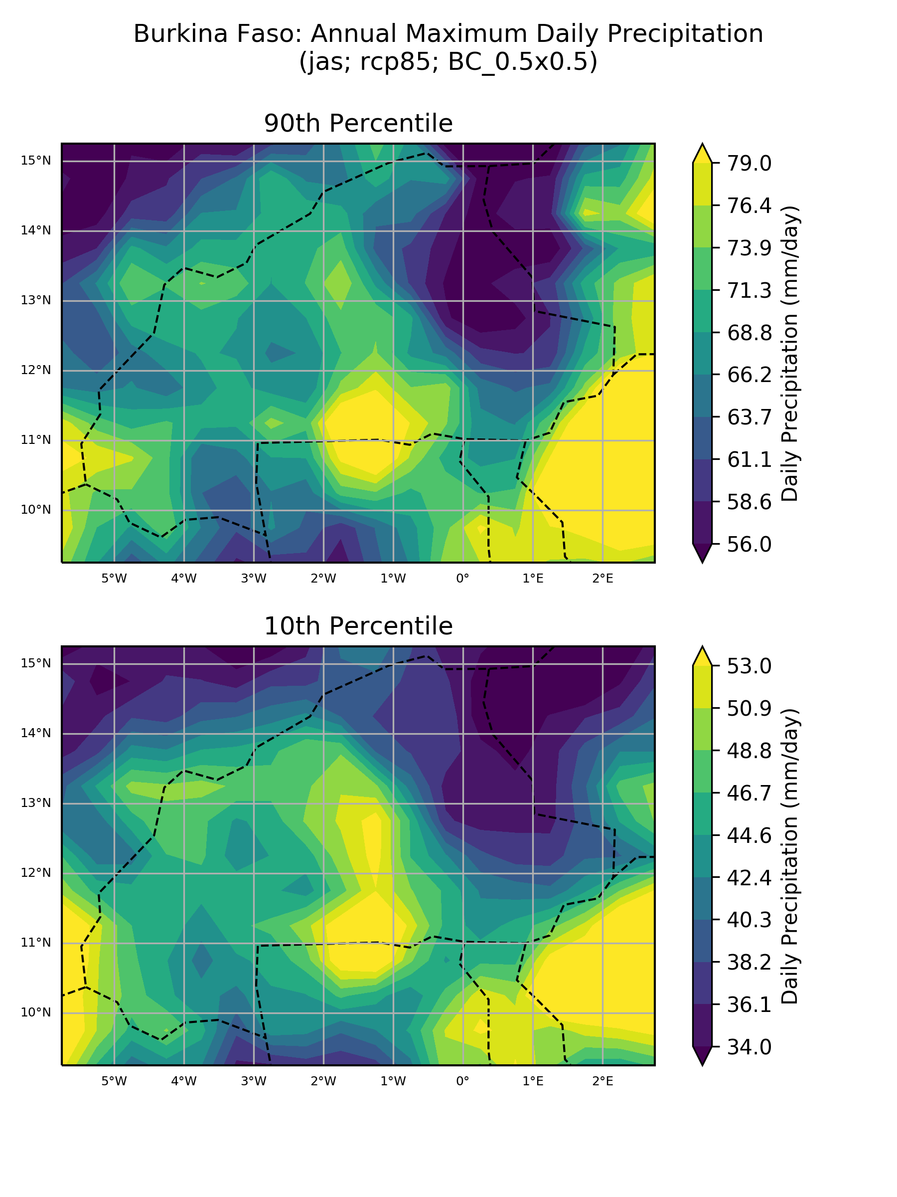

### Absolute anomaly (one scenario)

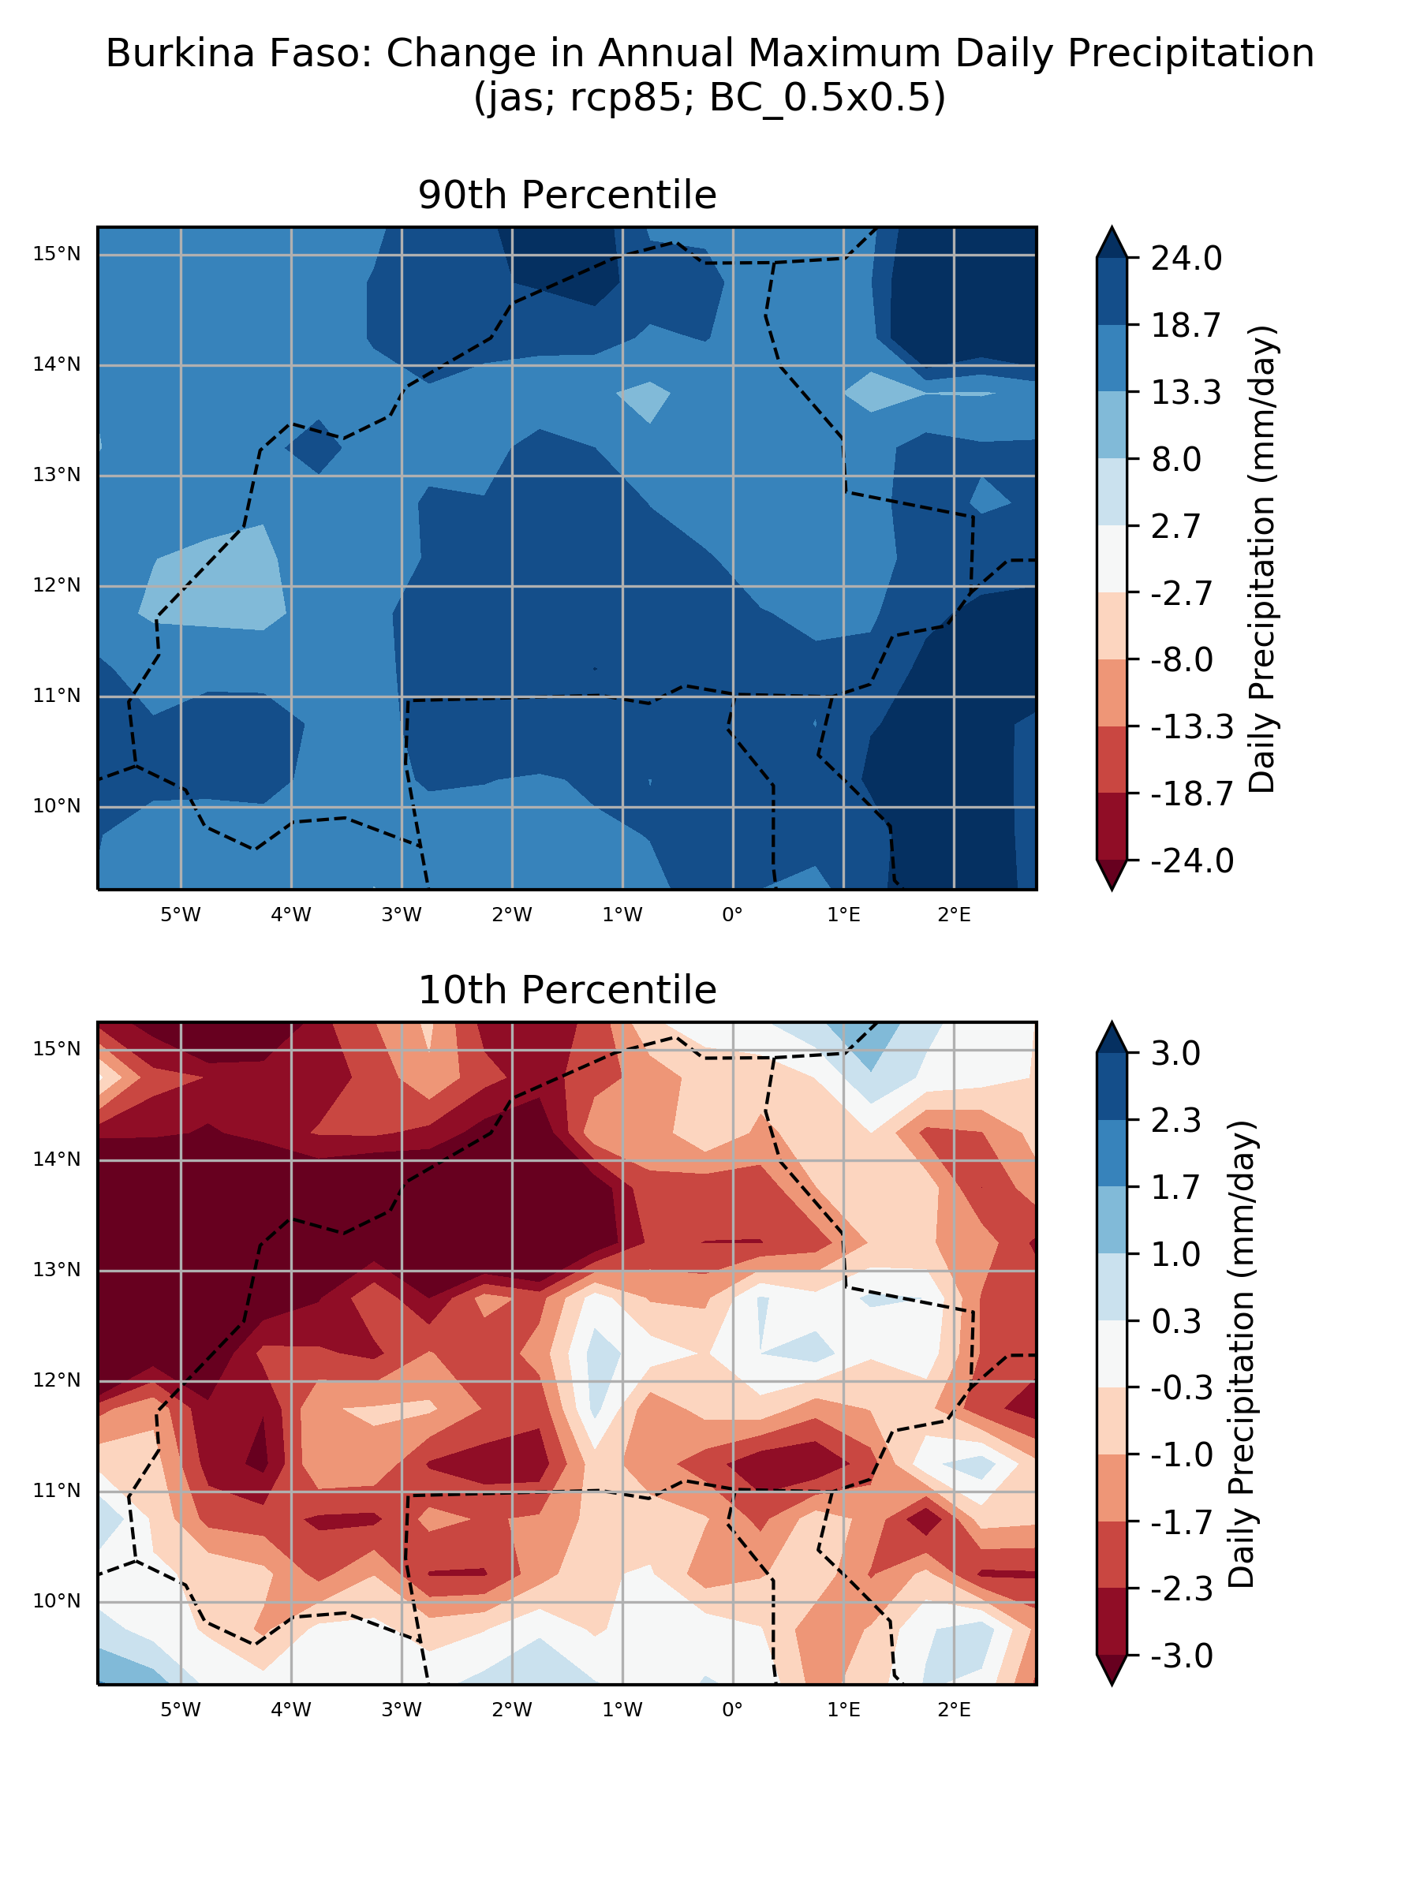

### % anomaly (one scenario)

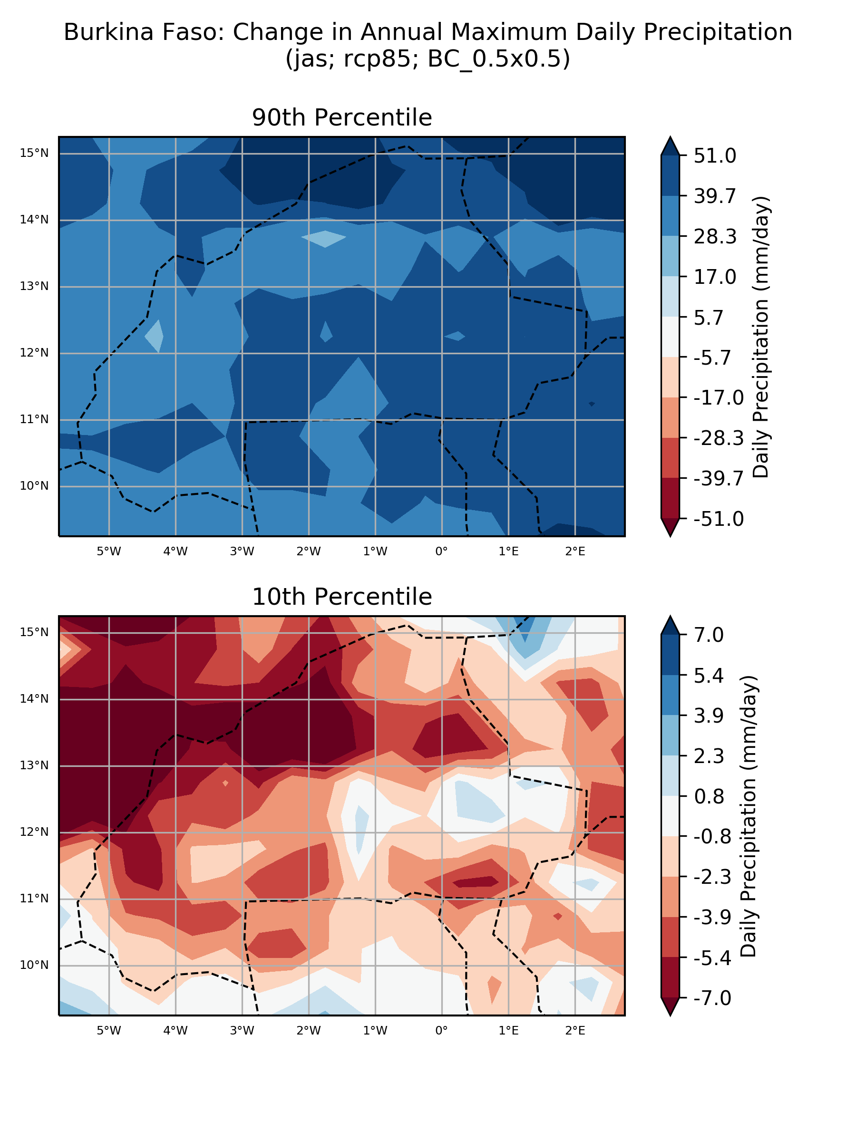

## ‘Number of model’ histograms

### Absolute anomaly (one scenario)

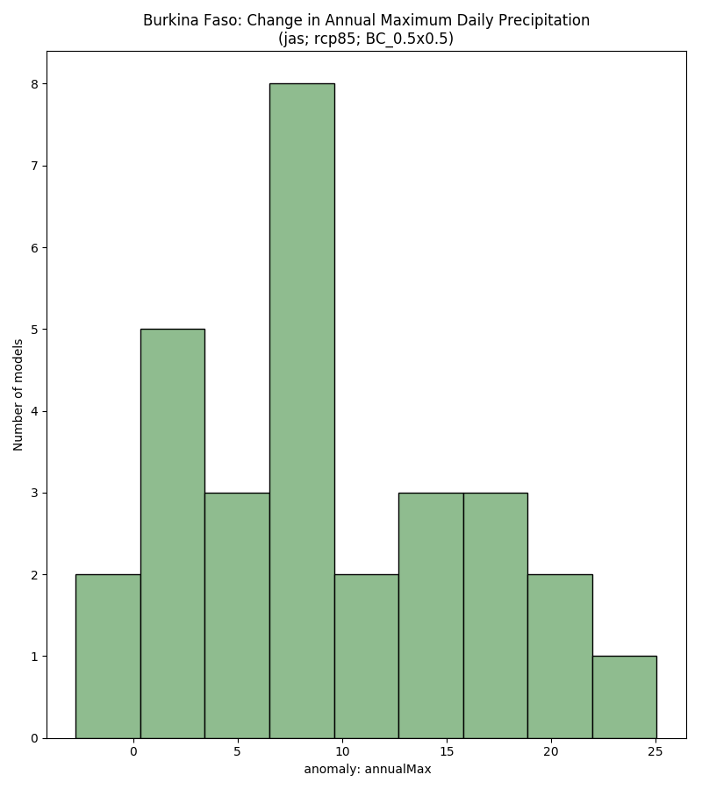

### % anomaly (one scenario)

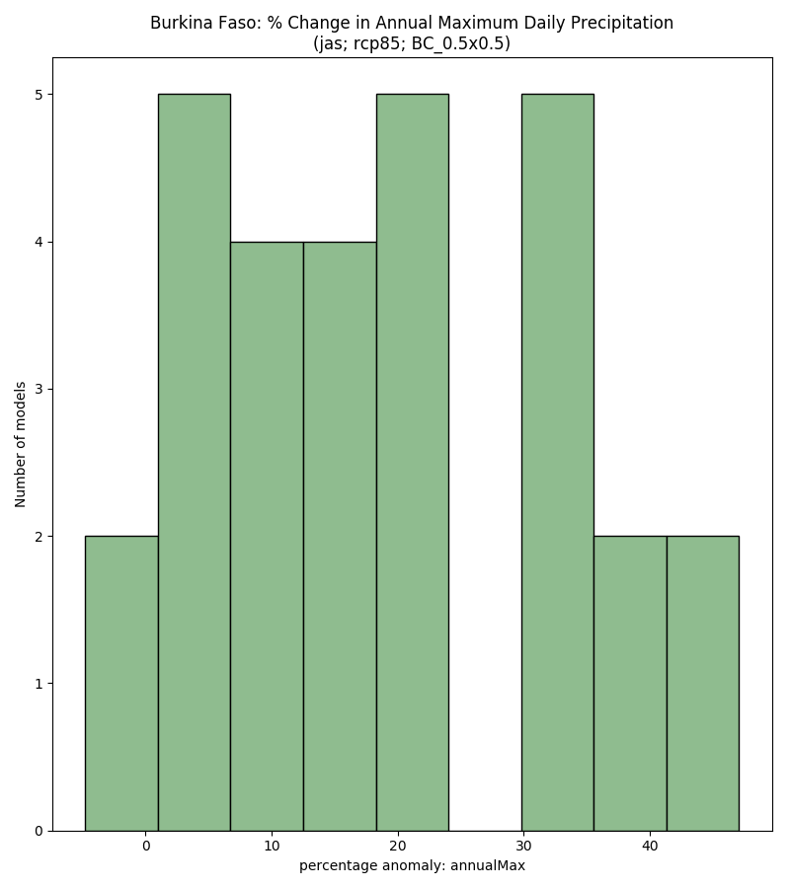

# Monsoon Onset (Marteau method)

## Boxplots

### Absolute anomaly by scenario

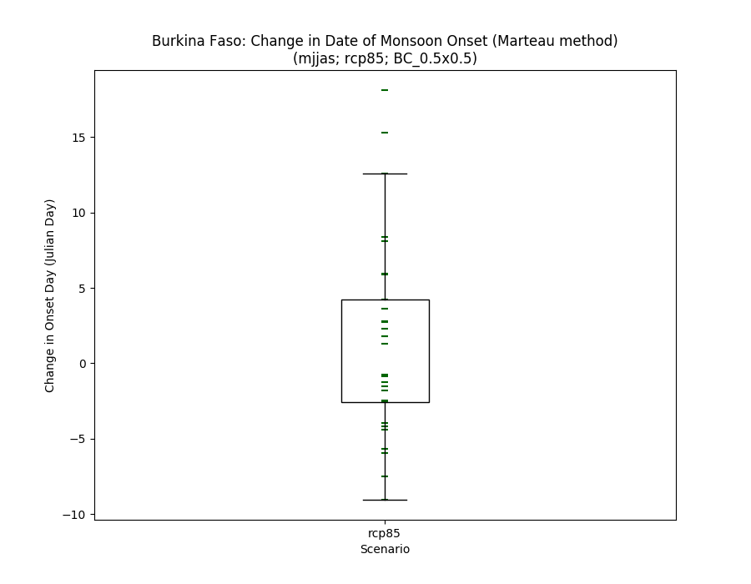

### % anomaly by scenario

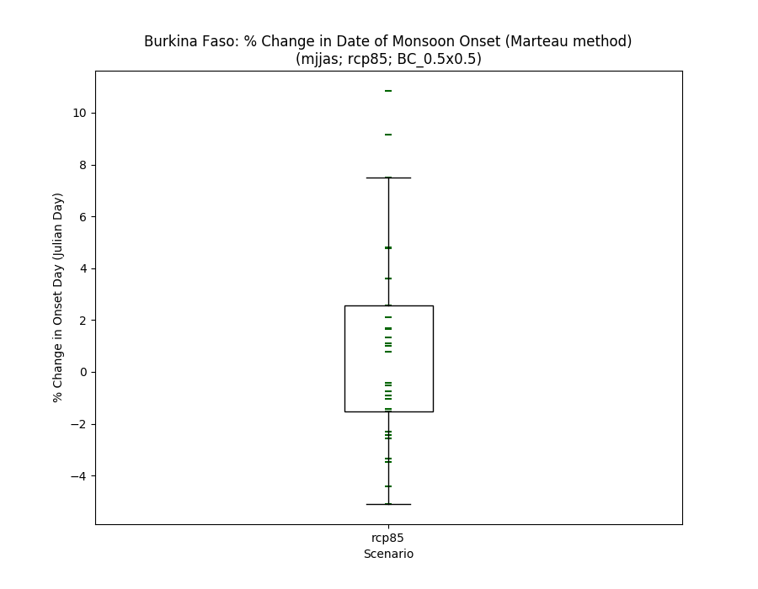

### Historical vs scenarios

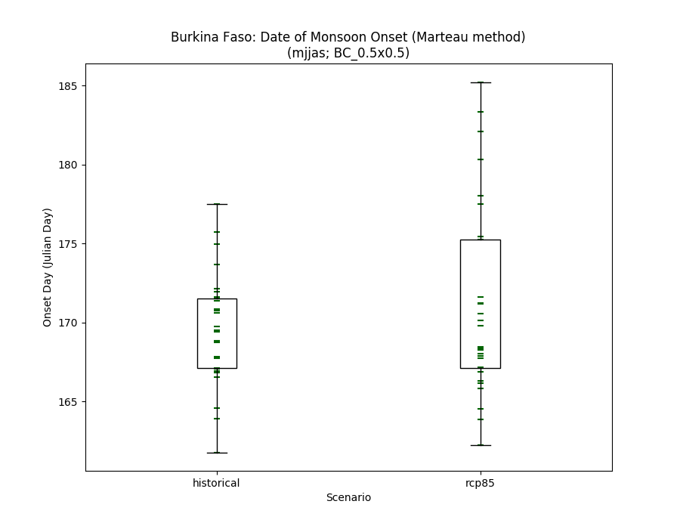

## Histograms

### Absolute anomaly (one scenario)

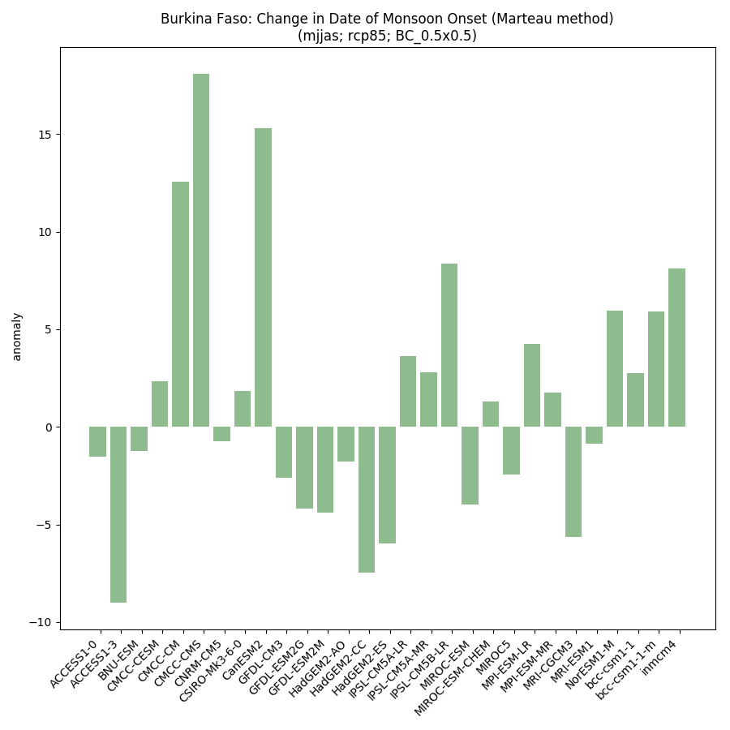

### % anomaly by scenario

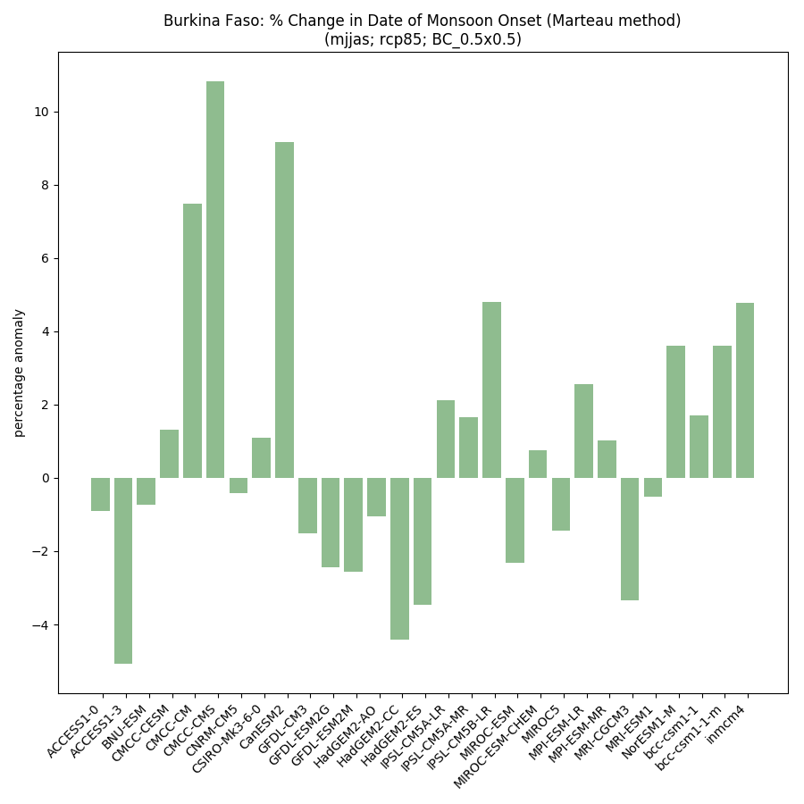

### Historical vs scenarios side-by-side

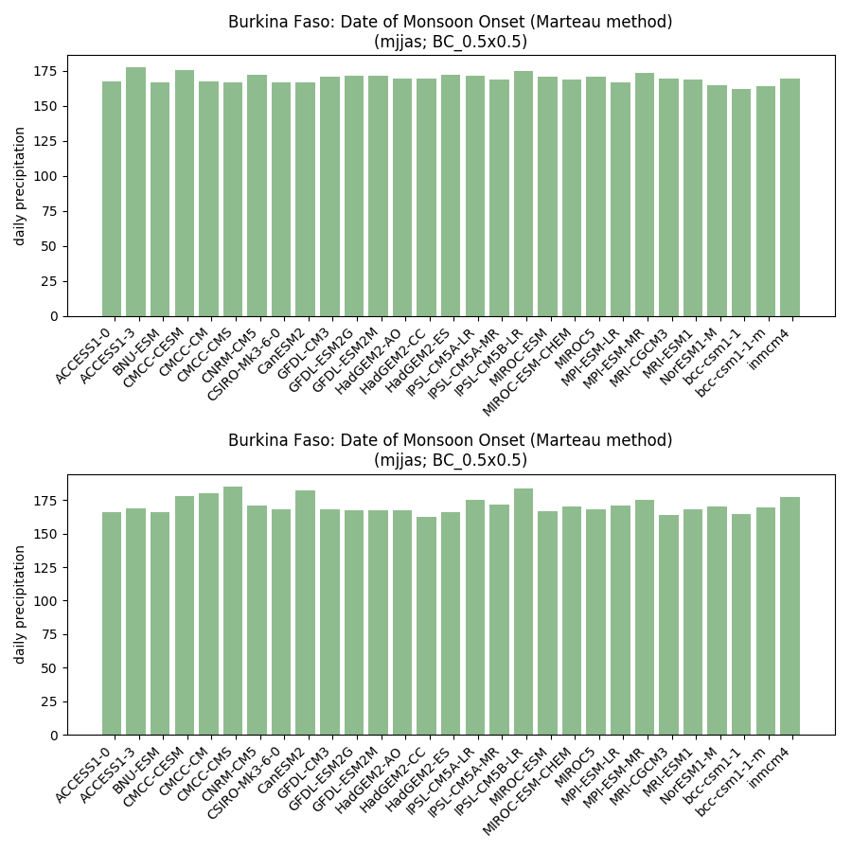

## Model ranking scatterplots

### Each scenario (and historical) individually

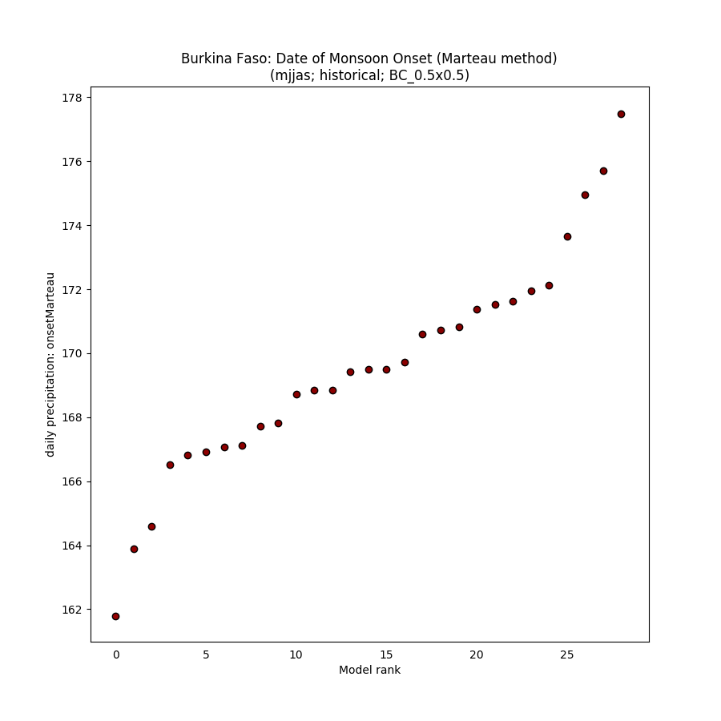

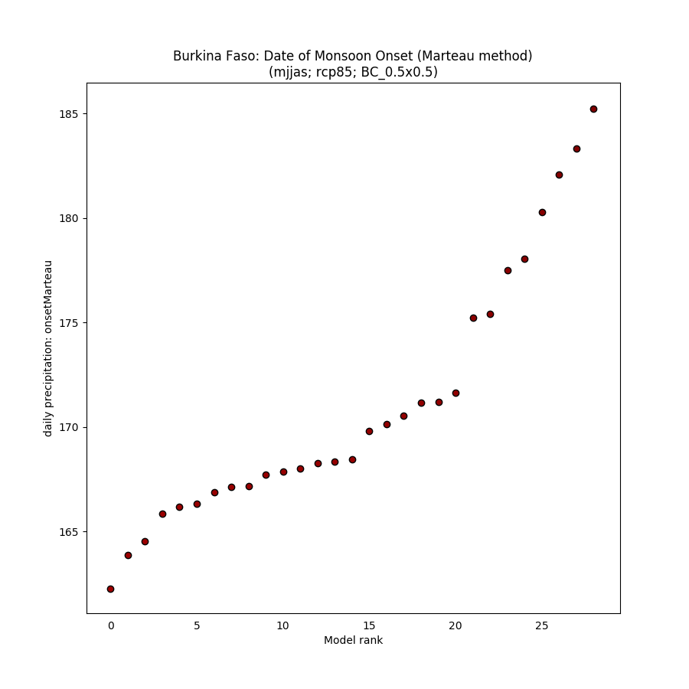

### Absolute anomaly (one scenario)

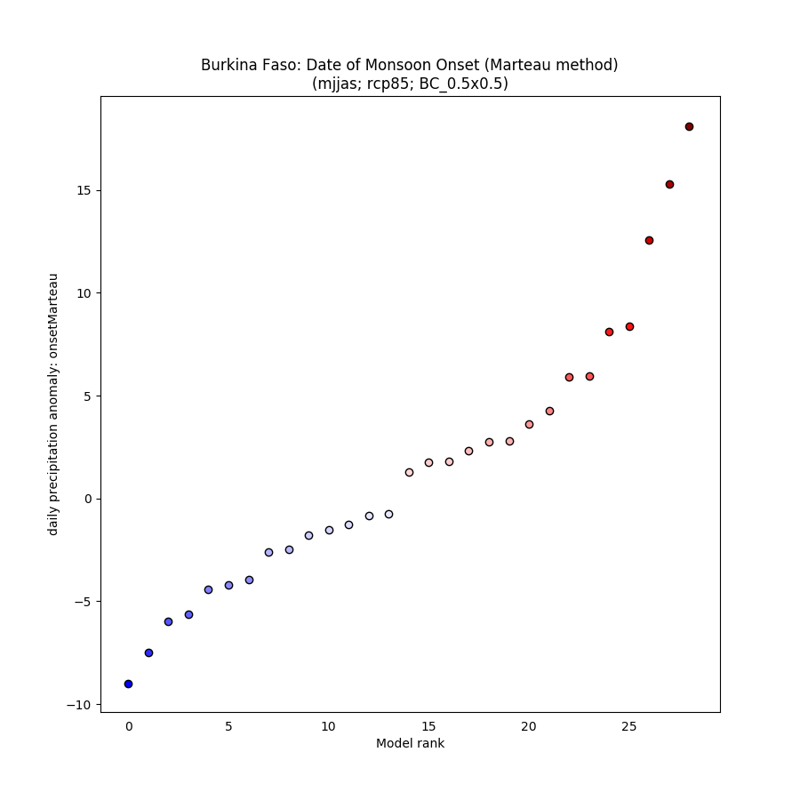

### % anomaly (one scenario)

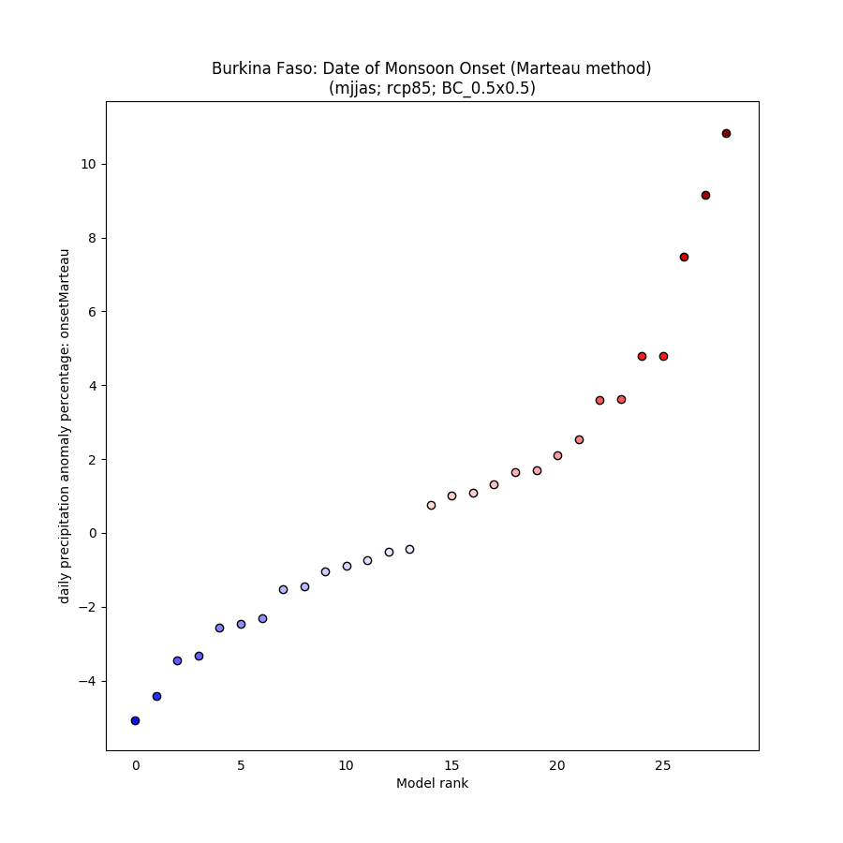

## Spaghetti timeseries

### All scenarios for 1950-2100

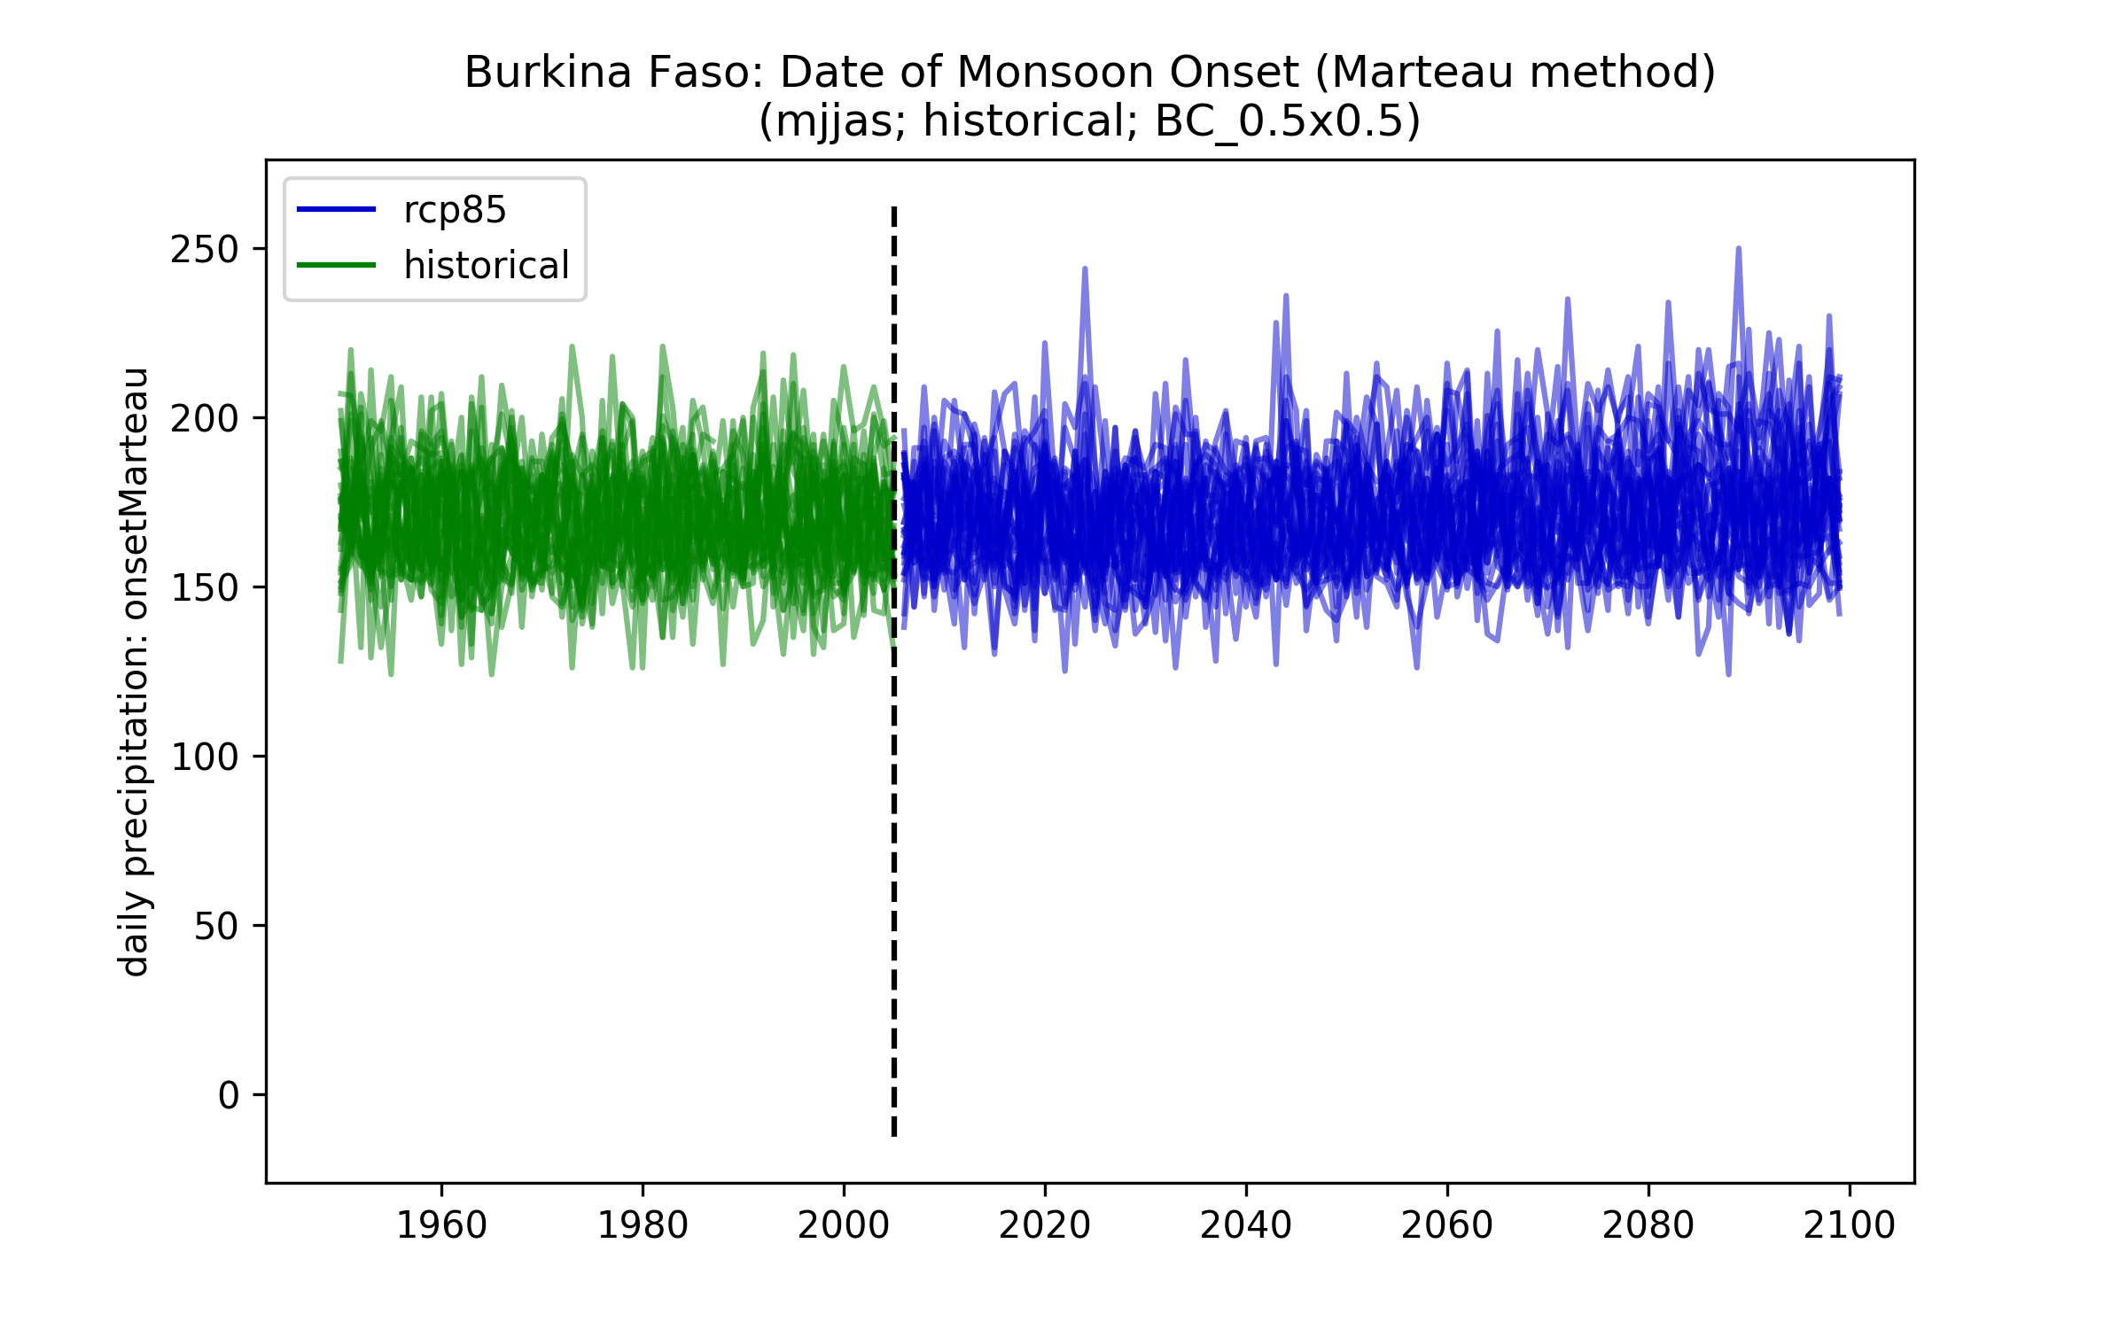

## Maps of ensemble spread (10th and 90th percentiles)

### Each scenario (and historical) individually

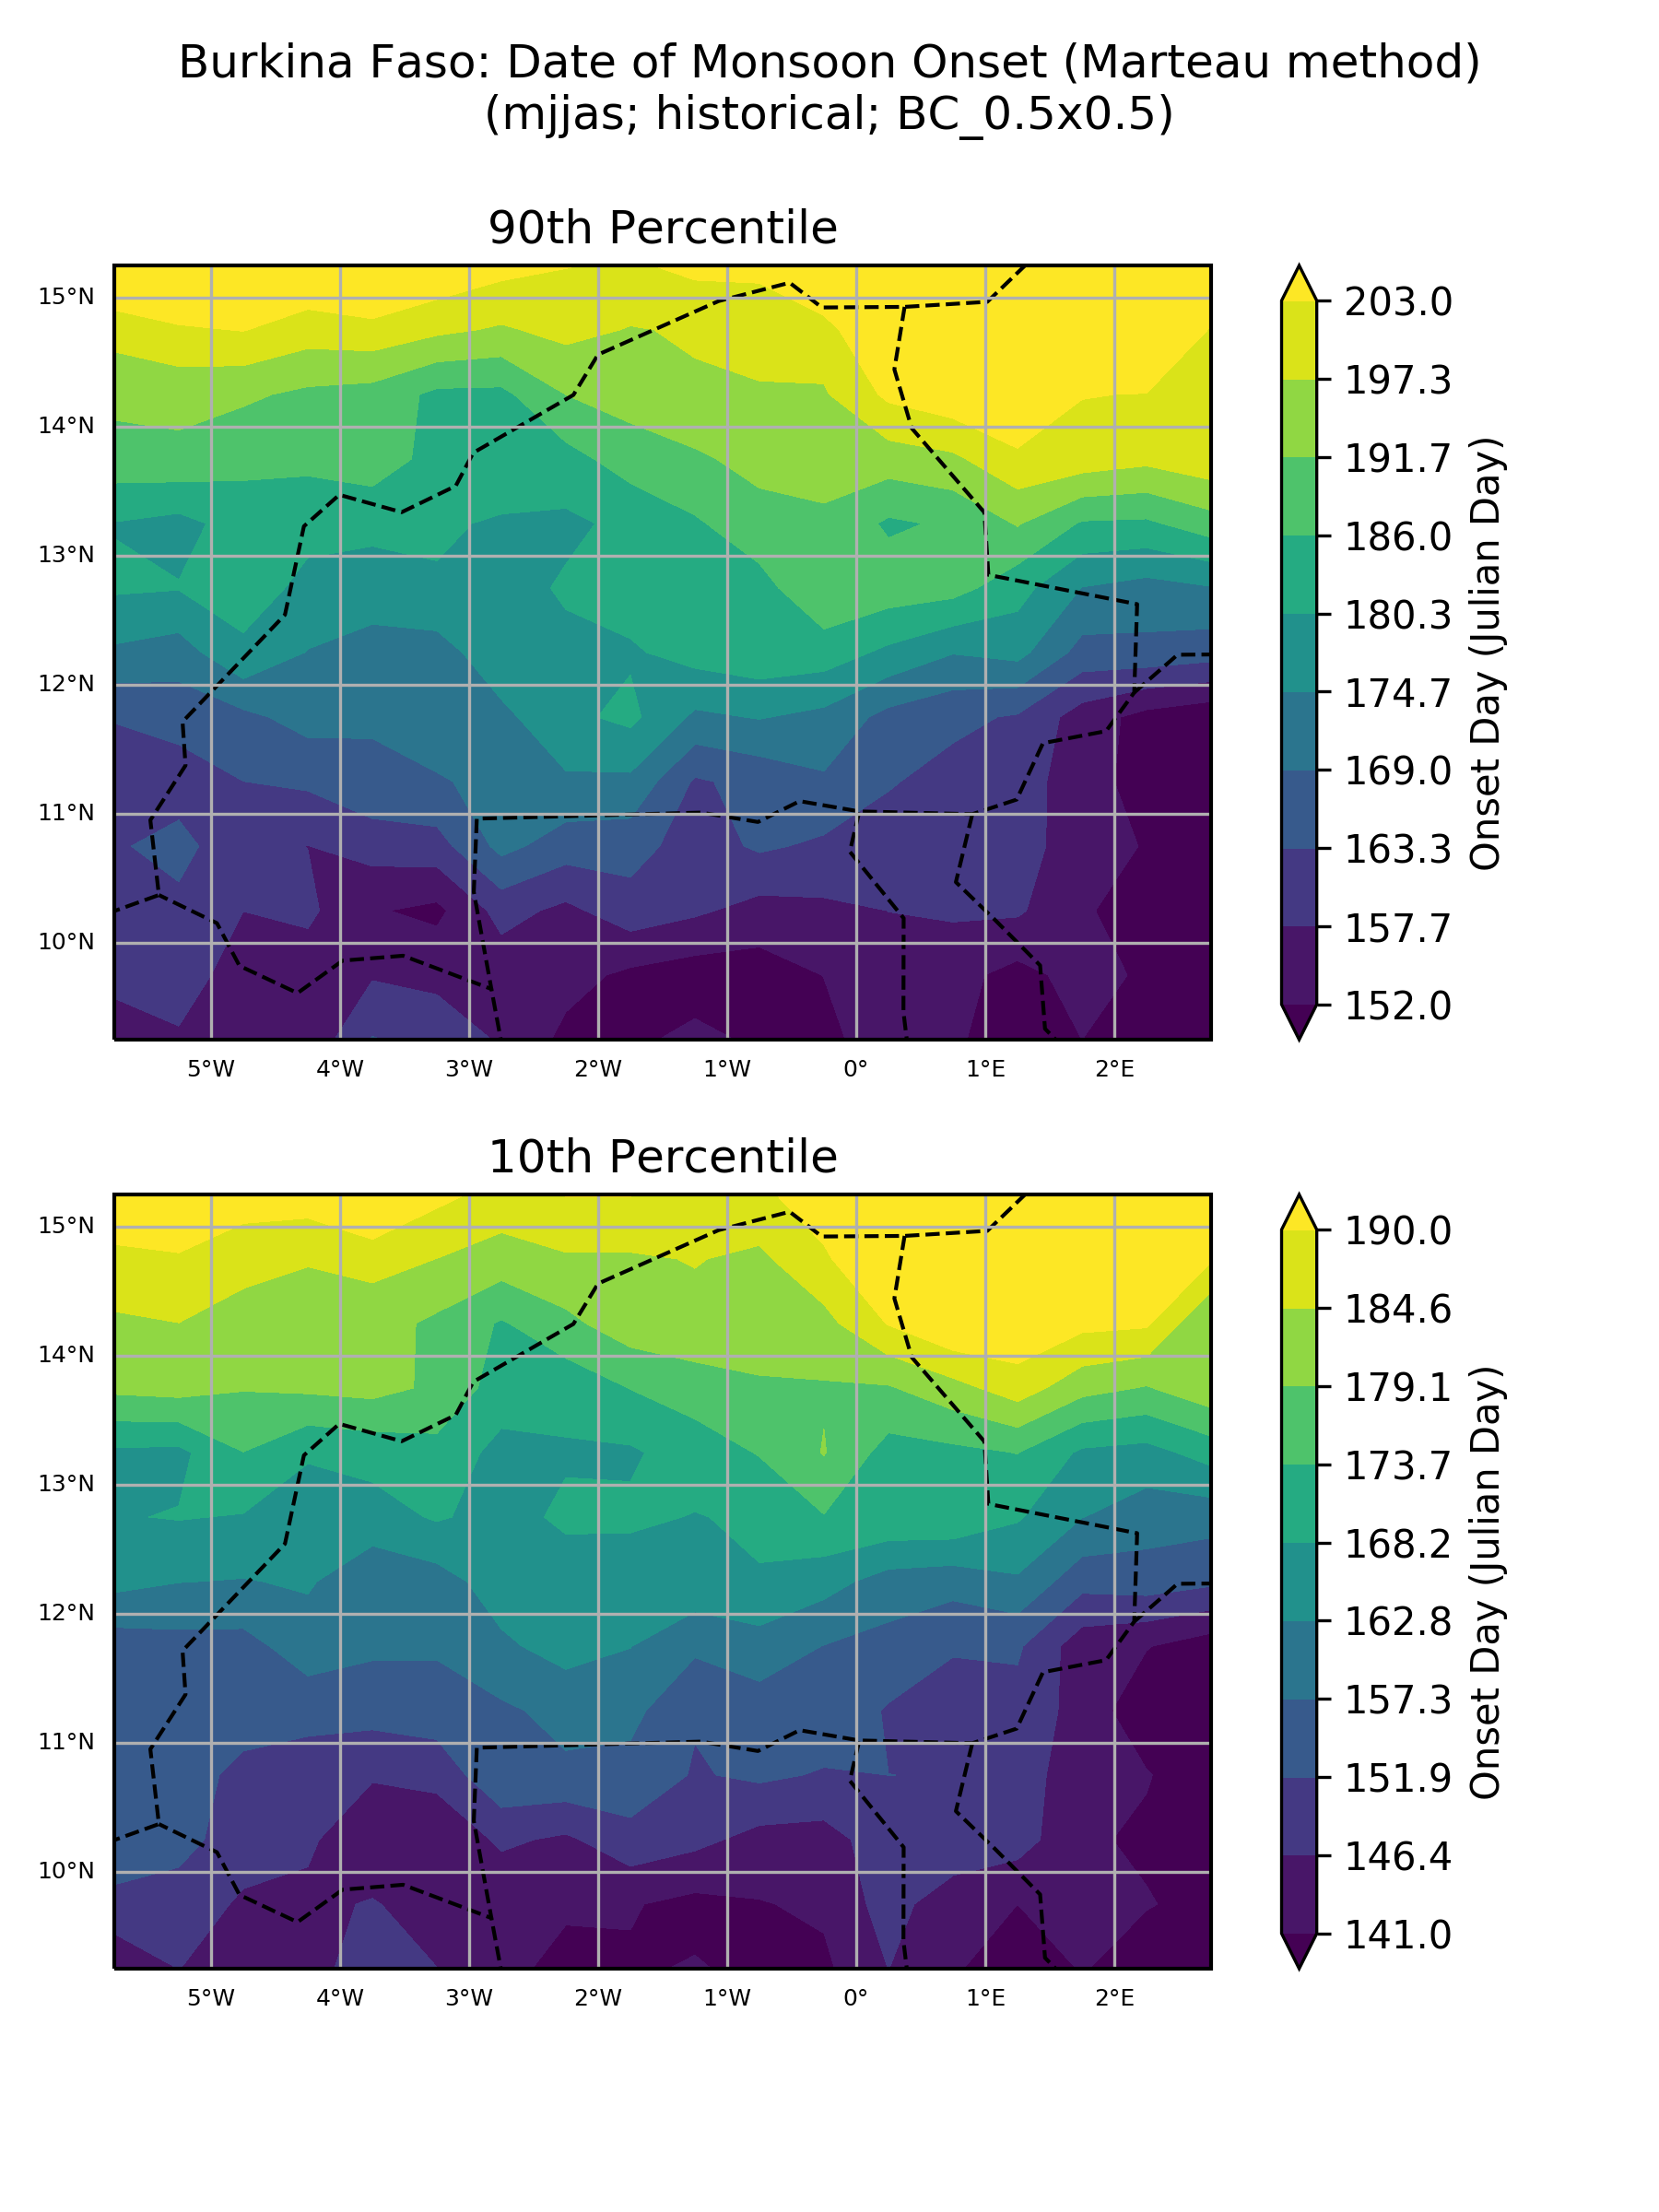

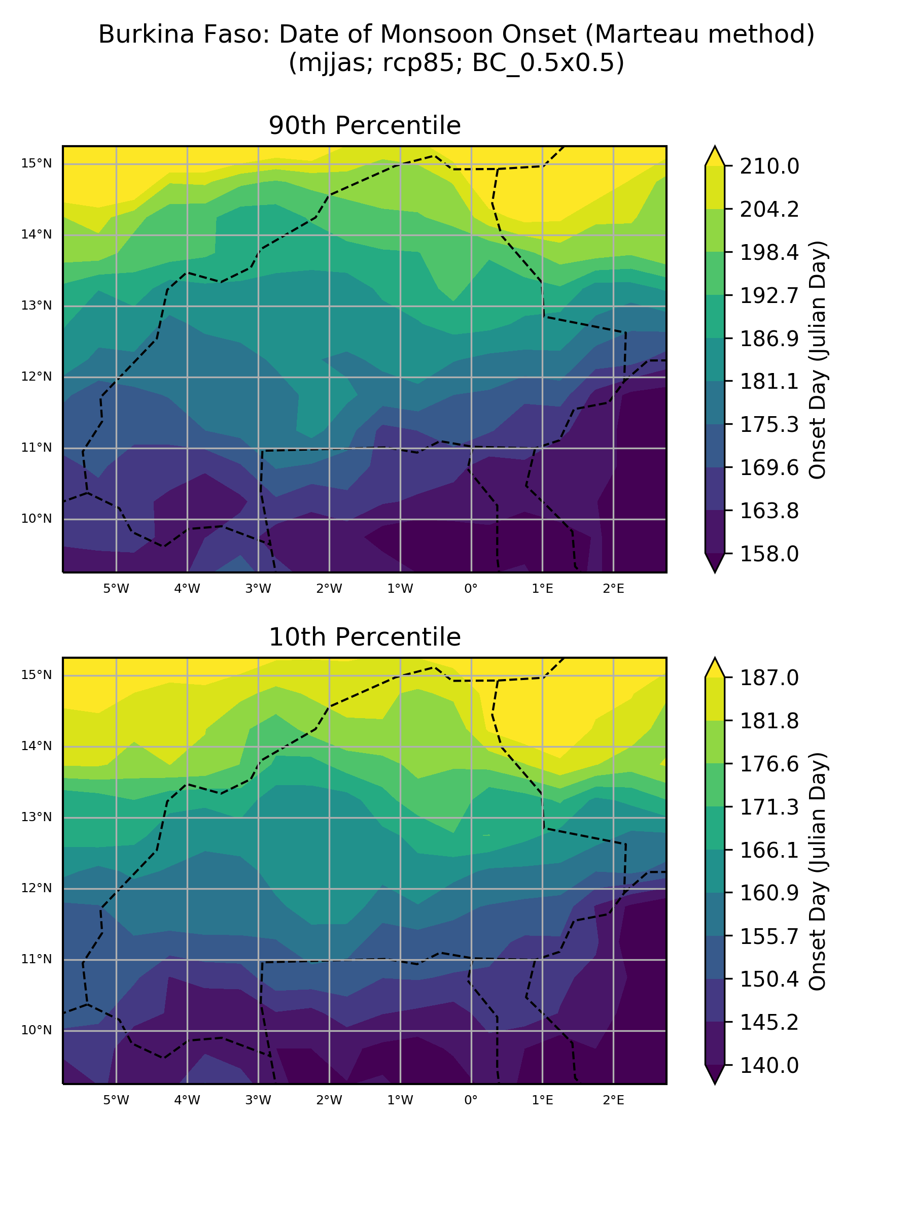

### Absolute anomaly (one scenario)

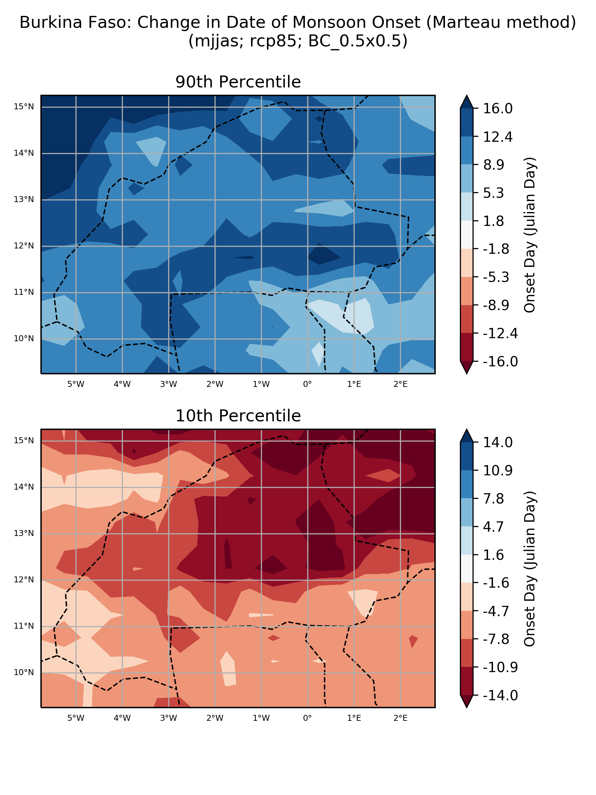

### % anomaly (one scenario)

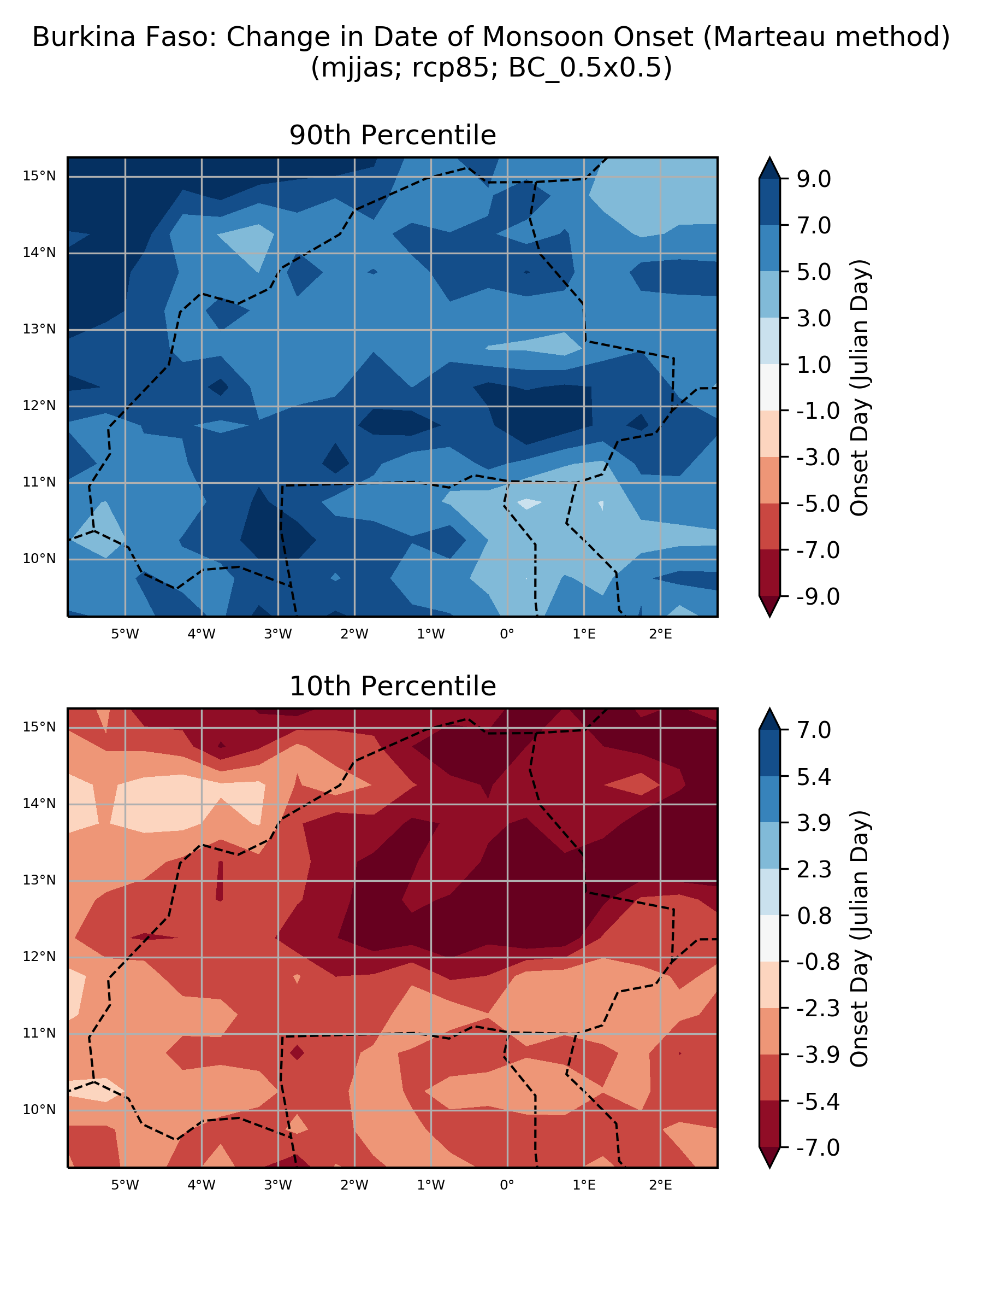

## ‘Number of model’ histograms

### Absolute anomaly (one scenario)

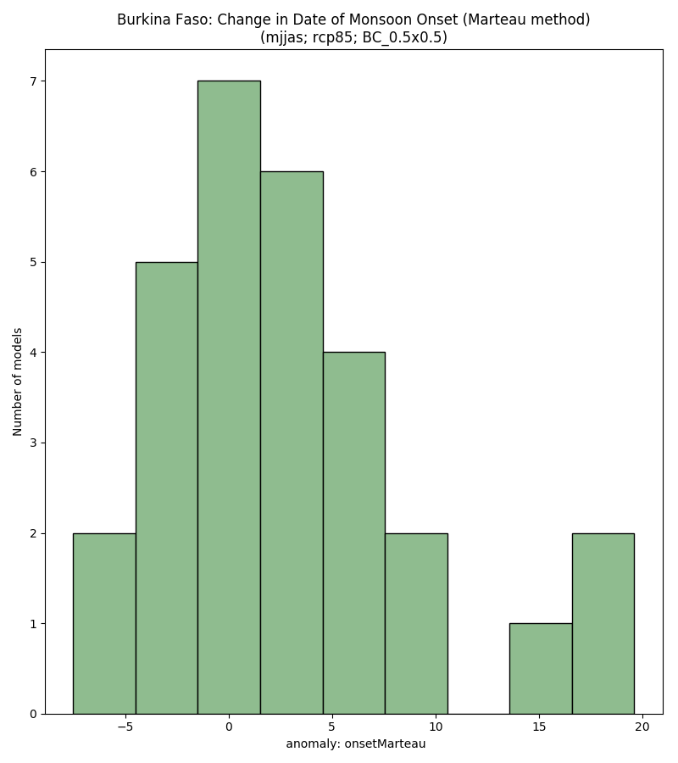

### % anomaly (one scenario)

